Violence against women



**Violence against women**

**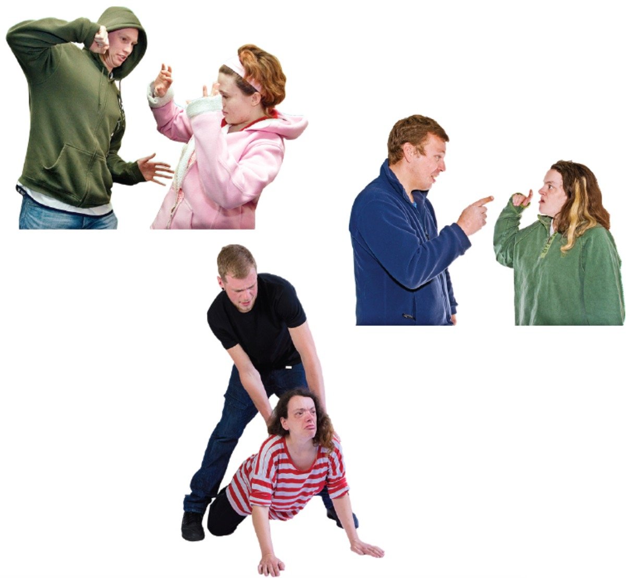**

**What is in this book**

Inside this book you will read about:

|  |  |  |
| --- | --- | --- |
| florence:Users:andrew:Documents:Andrew's WIP:FRA:Photosymbols:Read-5_grande.png | **Who wrote this book** | **Page 4** |
| florence:Users:andrew:Desktop:Easy Read clipart:law book.jpeg | **Laws against hurting women** | **Page 5** |
| florence:Users:andrew:Documents:Andrew's WIP:FRA:Photosymbols:Market-Research_grande.png | **The survey** | **Page 6** |
| florence:Users:andrew:Documents:Andrew's WIP:FRA:Photosymbols:Idea2_grande.png | **What is wrong and what to do about it** | **Page 9** |

**Who wrote this book**

|  |  |
| --- | --- |
| Vader-WIP:FRA:Resources:easy read materials:Easy Read clipart:FRAlogo.png | We are the **European Union Agency for Fundamental Rights**.  We wrote this book.  **We are called FRA for short.**  We are an **organisation**.  **An organisation is a group of people working together.** |
| florence:Users:andrew:Documents:Andrew's WIP:FRA:Photosymbols:EU-Map-In_392f901a-dd7f-4888-8bc1-9423ba1aac6a_grande.png | We help to make sure everyone  in the **European Union**  can use their **rights**.  **The European Union  is a group of 28 countries in Europe.** |
| florence:Users:andrew:Documents:Andrew's WIP:FRA:Photosymbols:Group-22_grande.png | **Rights are things that everyone has.**  For example, the right to vote  and the right to get married. |

**Laws against hurting women**

|  |  |
| --- | --- |
|  | There are rules against hurting women.  One of these rules is called the Istanbul Convention.  It is an important document.  Countries who agree with the Istanbul Convention must follow its rules. |
| C:\Users\melzeut\AppData\Local\Microsoft\Windows\INetCache\Content.Word\FreeVector-Hand-Icon.ai.jpg | The Istanbul Convention says that countries must have rules that protect  women against violence. |
| florence:Users:andrew:Documents:Andrew's WIP:FRA:Photosymbols:EU-Map-In_392f901a-dd7f-4888-8bc1-9423ba1aac6a_grande.png | The European Union has rules to help women who have been hurt. |
| florence:Users:andrew:Desktop:Easy Read clipart:law book.jpeg | One of these rules is called the Victims Rights’ Directive.  It lists the rights that victims of crime have.  It says that countries in the European Union must protect these rights. |

**The survey**

|  |  |
| --- | --- |
| ../../../../../Desktop/Survey%20question%20ma | A **survey** means asking a lot of people the same questions. |
| florence:Users:andrew:Documents:Andrew's WIP:FRA:Photosymbols:EU-Map-In_392f901a-dd7f-4888-8bc1-9423ba1aac6a_grande.png | We asked more than 900 women  in every country of the **European Union**.  We asked over 40,000 women in total. |
| ../../../../../Desktop/Types%20of%20violenc | We asked if anyone had been **violent**  to them. |
| There are different types of **violence**. |

|  |  |
| --- | --- |
| florence:Users:andrew:Documents:Andrew's WIP:FRA:Photosymbols:Attack-3_grande.png | We asked women if anyone had been **physically violent** to them. |
| florence:Users:andrew:Documents:Andrew's WIP:FRA:Photosymbols:Shove-1_grande.png | **Physical violence is hurting somebody’s body.**  That means things like hitting, pushing  or choking them. |
| Macintosh HD:Users:lieke:Documents:Lieke's WIP:FRA:Photosymbols:Winterbourne-Abuse-1_grande.png | We asked women if anyone  had **raped** them or tried to rape them.  **Rape means forcing someone  to have sex with them.** |

|  |  |
| --- | --- |
| florence:Users:andrew:Documents:Andrew's WIP:FRA:Photosymbols:Argue_grande.png | We asked if their **partners** had **emotionally abused** them.  **Partners means husbands, wives, boyfriends or girlfriends.**  **Emotional abuse means  making someone feel ashamed  or afraid.** |
| florence:Users:andrew:Documents:Andrew's WIP:FRA:Photosymbols:Look_other_way_grande.png | We asked if anyone had **stalked** them.  **Being stalked means being followed  by someone they do not want to follow them.**  **Stalking can also happen on the internet.** |
| florence:Users:andrew:Documents:Andrew's WIP:FRA:Photosymbols:Law_758bcc9d-7bc0-4543-a00f-ec331d1bce0d_grande.png | We asked what they knew about laws  to stop anyone hurting them. |
| florence:Users:andrew:Documents:Andrew's WIP:FRA:Photosymbols:Idea2_grande.png | The **survey** helps us understand problems with violence against women  and what to do about it. |

**What is wrong and what to do about it**

|  |  |  |
| --- | --- | --- |
| ../../../../../Desktop/Woman%20red%20circ | | About one in three women say  someone has **hurt them physically**. |
| Macintosh HD:Users:lieke:Documents:Lieke's WIP:FRA:Photosymbols:My_rights_grande.png | Macintosh HD:Users:lieke:Documents:Lieke's WIP:FRA:Photosymbols:My_rights_grande.png |
| ../../../../../Desktop/Most%20women%20don't%20tell%20p | | Most women don’t tell the police  when someone hurts them. |
| florence:Users:andrew:Documents:Andrew's WIP:FRA:Photosymbols:GP_Doctor-3_grande.png | | We say that we should let  doctors and nurses ask patients  if someone has hurt them. |

|  |  |
| --- | --- |
| florence:Users:andrew:Documents:Andrew's WIP:FRA:Photosymbols:Police_help_grande.png | We say the police  should have special people  to help women who have been hurt.  These special people know how to help. |
| Macintosh HD:Users:lieke:Documents:Lieke's WIP:FRA:Photosymbols:Annabelle-Upset-Comfort_grande.png | We need to find out  if people are helping women. |

|  |  |
| --- | --- |
| ../../../../../Desktop/Woman%20red%20circMacintosh HD:Users:lieke:Documents:Lieke's WIP:FRA:Photosymbols:My_rights_grande.pngMacintosh HD:Users:lieke:Documents:Lieke's WIP:FRA:Photosymbols:My_rights_grande.pngMacintosh HD:Users:lieke:Documents:Lieke's WIP:FRA:Photosymbols:My_rights_grande.pngMacintosh HD:Users:lieke:Documents:Lieke's WIP:FRA:Photosymbols:My_rights_grande.pngMacintosh HD:Users:lieke:Documents:Lieke's WIP:FRA:Photosymbols:My_rights_grande.pngMacintosh HD:Users:lieke:Documents:Lieke's WIP:FRA:Photosymbols:My_rights_grande.pngMacintosh HD:Users:lieke:Documents:Lieke's WIP:FRA:Photosymbols:My_rights_grande.pngMacintosh HD:Users:lieke:Documents:Lieke's WIP:FRA:Photosymbols:My_rights_grande.pngMacintosh HD:Users:lieke:Documents:Lieke's WIP:FRA:Photosymbols:My_rights_grande.pngMacintosh HD:Users:lieke:Documents:Lieke's WIP:FRA:Photosymbols:My_rights_grande.pngMacintosh HD:Users:lieke:Documents:Lieke's WIP:FRA:Photosymbols:My_rights_grande.pngMacintosh HD:Users:lieke:Documents:Lieke's WIP:FRA:Photosymbols:My_rights_grande.pngMacintosh HD:Users:lieke:Documents:Lieke's WIP:FRA:Photosymbols:My_rights_grande.pngMacintosh HD:Users:lieke:Documents:Lieke's WIP:FRA:Photosymbols:My_rights_grande.pngMacintosh HD:Users:lieke:Documents:Lieke's WIP:FRA:Photosymbols:My_rights_grande.pngMacintosh HD:Users:lieke:Documents:Lieke's WIP:FRA:Photosymbols:My_rights_grande.pngMacintosh HD:Users:lieke:Documents:Lieke's WIP:FRA:Photosymbols:My_rights_grande.pngMacintosh HD:Users:lieke:Documents:Lieke's WIP:FRA:Photosymbols:My_rights_grande.pngMacintosh HD:Users:lieke:Documents:Lieke's WIP:FRA:Photosymbols:My_rights_grande.png | About 1 out of 20 women say  someone has **raped** them. |
| Macintosh HD:Users:lieke:Documents:Lieke's WIP:FRA:Photosymbols:Winterbourne-Abuse-1_grande.png | More women say someone  has tried to rape them. |
| ../../../../../Desktop/Most%20women%20don't%20tell%20p | Most women do not tell the police  when someone rapes them  or tries to rape them. |
| florence:Users:andrew:Documents:Andrew's WIP:FRA:Photosymbols:Police_help_grande.png | We say the police need to know  how to help women who have been raped. |
| Macintosh HD:Users:lieke:Documents:Lieke's WIP:FRA:Photosymbols:Comfort1_grande.png | We say we need to help women to feel OK about telling people  when someone has raped or hurt them or tried to rape or hurt them. |

|  |  |
| --- | --- |
| ../../../../../Desktop/Woman%20red%20circMacintosh HD:Users:lieke:Documents:Lieke's WIP:FRA:Photosymbols:My_rights_grande.png | Almost half of women say their partner has **emotionally abused** them.  For example, the partner made the woman feel ashamed or afraid. |
| ../../Teach1.pdf | People at work need to know  when other workers  have been emotionally abused.  We say employers  should train workers to know  about emotional abuse. |
| florence:Users:andrew:Documents:Andrew's WIP:FRA:Photosymbols:Police_help_grande.png | We say the police should learn  to know when people feel bad  because of what their partners are doing. |
| ../../Classroom2.pdf | We need to teach people  not to emotionally abuse their partners. |

|  |  |
| --- | --- |
| ../../../../../Desktop/Woman%20red%20circMacintosh HD:Users:lieke:Documents:Lieke's WIP:FRA:Photosymbols:My_rights_grande.png  Macintosh HD:Users:lieke:Documents:Lieke's WIP:FRA:Photosymbols:My_rights_grande.pngMacintosh HD:Users:lieke:Documents:Lieke's WIP:FRA:Photosymbols:My_rights_grande.pngMacintosh HD:Users:lieke:Documents:Lieke's WIP:FRA:Photosymbols:My_rights_grande.png | Almost 1 in 5 women say  someone has stalked them. |
| ../../../../../Desktop/Most%20women%20don't%20tell%20p | Most women do not tell the police  when someone stalks them. |
| ../../Photosymbols/Statement2_grande.png | We should help women  feel that they can report stalking. |
| ../../Photosymbols/Prisoners_grande.png | We say countries  should keep women safe from stalkers. |
| florence:Users:andrew:Documents:Andrew's WIP:FRA:Photosymbols:Comfort1_grande.png | We should have people who know  how to help women feel better  after someone has stalked them. |

|  |  |
| --- | --- |
| ../../../../../Desktop/Woman%20red%20circMacintosh HD:Users:lieke:Documents:Lieke's WIP:FRA:Photosymbols:My_rights_grande.png | Half of all women stay away  from some places because they are scared. |
| ../../../../../Desktop/Women%20more%20likely%20to%20be%20scared%20if%2 | Women are more likely to be scared  if someone has hurt them before. |
| florence:Users:andrew:Documents:Andrew's WIP:FRA:Photosymbols:Scared-2_grande.png | When a woman looks scared,  it would be good to ask her  if she needs help.  She may have been hurt. |

|  |  |
| --- | --- |
| florence:Users:andrew:Documents:Andrew's WIP:FRA:Photosymbols:Attack-3_grande.png | Most women think  people often hurt women. |
| ../../../../../Desktop/Know%20abused%20woma | Almost half of women know  a woman who has been hurt. |
| ../../../../../Desktop/Woman%20red%20circMacintosh HD:Users:lieke:Documents:Lieke's WIP:FRA:Photosymbols:My_rights_grande.png | Only half of women know  that there are laws  against hurting women. |
| florence:Users:andrew:Documents:Andrew's WIP:FRA:Photosymbols:GP_Doctor-3_grande.png | Sometimes a doctor thinks a woman looks as if she has been hurt.  Most women think the doctor  should ask her  if anyone has been violent to her. |

|  |  |
| --- | --- |
| florence:Users:andrew:Documents:Andrew's WIP:FRA:Photosymbols:EU-Map-In_392f901a-dd7f-4888-8bc1-9423ba1aac6a_grande.png | We say countries should make plans to stop people hurting women. |
| ../../../../../Desktop/EU%20money%20to%20wo | We say the European Union should give organisations money  to help women who have been hurt. |
| ../../../../../Desktop/Don't%20ignore%20violenc | Some people think it is nobody else’s business if partners hurt each other.  We say no.  When someone hurts their partner,  it is important  that this does not remain a secret.  Other people need to know  this is happening. |
| florence:Users:andrew:Documents:Andrew's WIP:FRA:Photosymbols:Law_758bcc9d-7bc0-4543-a00f-ec331d1bce0d_grande.png | There should be laws against partners hurting each other. |
| florence:Users:andrew:Documents:Andrew's WIP:FRA:Photosymbols:Market-Research_grande.png | To see if the laws are working,  we need to know  what is happening to women.  If we know what is happening  to women,  then we can decide what to do about it.  We should ask women these questions again in the future. |
| This book was developed thanks to the support of Mencap Liverpool. | |