

The right to political participation of persons with mental health problems and persons with intellectual disabilities

October 2010
The report addresses matters most closely related to the principle of non-discrimination (Article 21), the integration of persons with disabilities (Article 26), the right to vote and to stand as a candidate at elections to the European Parliament (Article 39) and the right to vote and to stand as a candidate at municipal elections (Article 40) falling under the Chapters III ‘Equality’ and V ‘Citizens’ rights’ of the Charter of Fundamental Rights of the European Union.

Foreword
Since the entry into force of the UN Convention on the Rights of Persons with Disabilities (CRPD) on 3 May 2008, 16 EU Member States have ratified the CRPD as of September 2010 and many more are at various stages of the ratification process. Now, with the anticipated accession of the European Union to the CRPD, protection of the rights of persons with disabilities will take another major step forward. The first ratification of an international human rights treaty by the EU marks a significant development in itself. For persons with disabilities, it means concretely that the rights and principles of the CRPD will be upheld EU-wide and that performances of the EU and the Member States will be under international scrutiny.
The CRPD requires a paradigmatic shift in the way our societies consider persons with disabilities. They are now explicitly recognised as fundamental rights holders on an equal legal footing with every other individual. The most significant development and challenge embedded in the CRPD, which is at the heart of ensuring that rights on paper are put into practice, is as follows: rather than persons with disabilities having to fit into the way society is organised, the onus is now on society to adapt to and accommodate persons with disabilities specific needs. The close monitoring of changes in practice will see this ambition becomes a reality.
This is the first project of the European Union Agency for Fundamental Rights (FRA) in the area of disability. It is carried out in the spirit of the CRPD. The project aims to assess the fundamental rights situation of some of the most vulnerable groups of persons with disabilities, namely those with mental health problems and those with intellectual disabilities.
This specific report on the right to political participation of persons with intellectual disabilities and persons with mental health problems presents the preliminary results drawn from the legal component of the study. The right to vote and to be elected was chosen because it is a fundamental right that all citizens in the Union should be able to enjoy, on an equal basis. The report highlights international and European standards in this area and analyses the current legal framework in all 27 EU Member States, with the intention of contributing to knowledge about and the process of reform currently taking place in the EU Member States.
Morten Kjærum
Director

Table of contents
Foreword 3
Introduction 6
1. International and European Standards 8
1.1. A general right to political participation 8
1.2. A right specifically guaranteed to persons with intellectual disabilities and persons with mental health problems 12
2. The political participation spectrum 17
2.1. Exclusion from political participation 17
2.2. Limited political participation 20
2.3. Full political participation 22
3. The Way Forward 24
Annex 28

Table of maps
Map 1: Exclusion from the right of political participation
in the European Union 18
Map 2: Limited political participation in the European Union 20
Map 3: Full political participation in the European Union 23

Introduction
In 2009, the European Union Agency for Fundamental Rights (FRA) started its first project in the area of disability. This three-year project will assess the fundamental rights protection of persons with mental health problems and persons with intellectual disabilities. The project follows an established FRA socio-legal approach, which consists of legal research in 27 EU Member States during 2009-2010 and is complemented with sociological research on the ground in eight EU Member States. Research is supported by the development of networks of partners advising the FRA with regard to the development and direction in the work. A dedicated and adapted communication policy will be developed in order to ensure that the research target groups are encompassed and are provided with accessible information.
The FRA has decided to start its work in the area of disability by focusing on what the European Court of Human Rights (ECtHR) has described as “a particularly vulnerable group in society, who have suffered considerable discrimination in the past”, namely, persons with intellectual disabilities and persons with mental health problems. While recognising that these are two separate groups, both suffer similar fates as they are too often stigmatised and excluded by society.
It is difficult to find an agreement on a definition of the two groups studied. Nonetheless, the report will use the following definitions:
A person with intellectual disability has life-long development needs. Intellectual disability is a condition of slow development, where medication has no effect.
A person with mental health problems is a patient. Mental illness can be cured or stabilised with medication, psychotherapy or other support systems.
The FRA is aware that depending on the jurisdiction, the country or the organisation, different terms are used to refer to the two groups of individuals studied. After careful consultation with partner organisations representing these groups of persons, the Agency has decided to refer to “persons with intellectual disabilities” and “persons with mental health problems”. In some cases, in order to avoid repetition, the reader will find a reference to “persons with disabilities”; such reference is done in the spirit of the UN Convention on the Rights of Persons with Disabilities (CRPD) and is not intended in any way to undermine the differences between both groups.
One of the Agency’s key tasks is to provide EU Institutions and EU Member States with comparable information on the situation in the Union. At a time when the European Union as well as its 27 Member States are in the process of acceding to the CRPD, the FRA, pursuant to its role, collected information on the fundamental rights situation of persons with disabilities in the Union. This information is complementary to the work of other organisations such as the Council of Europe (CoE), which is currently in the process of implementing its comprehensive Disability Action Plan (2006-2015).
While further results from the FRA disability project will be published in the course of 2011 and 2012, the Agency is publishing preliminary findings drawn from the legal research. This research has already been carried out in order to assist EU Member States who are presently undertaking reforms in this area.
The FRA chose to publish a short report on the right to political participation, which forms one part of a wider study on the fundamental rights of persons with mental health problems and persons with intellectual disabilities, for two main reasons. The right to vote is essential in our democratic countries. Furthermore, it exemplifies the three key principles of the disability strategy grounded in the CRPD, namely: non-discrimination, equality and active inclusion.
The findings presented here are based on data collected by the FRA FRALEX network of legal experts. Additional information was gathered through exchanges with key partners including the European Commission Disability High Level Group, the European Co-ordination Forum for the Council of Europe Disability Action Plan (2006-2015), two major non-governmental organisations (NGOs) in this field, Mental Health Europe and Inclusion Europe, and several national human rights institutions working in the area of disability. The FRA expresses its gratitude for these valuable contributions. The Agency emphasises, however, that the conclusions contained in this report represent the views of the FRA and not necessarily any of its collaborating organisations.
This report begins with an analysis of the key international and European principles relating to the right to political participation. The situation in EU Member States is summarised and compared in Section 2. The report then presents the legal situation in the EU Member States and concludes with some possible ways forward.
- International and European standards
  - A general right to political participation
Article 21 of the Universal Declaration of Human Rights (1948)
(1) Everyone has the right to take part in the government of his country, directly or through freely chosen representatives. (…)
(3) The will of the people shall be the basis of the authority of government; this will shall be expressed in periodic and genuine elections which shall be expressed in periodic and genuine elections which shall be by universal and equal suffrage and shall be held by secret vote or by equivalent free voting procedures.
Article 25 of the International Covenant on Civil and Political Rights (1966)
Every citizen shall have the right and the opportunity, without any of the distinctions mentioned in article 2 and without unreasonable restrictions:
(a) To take part in the conduct of public affairs, directly or through freely chosen representatives;
(b) To vote and to be elected at genuine periodic elections which shall be by universal and equal suffrage and shall be held by secret ballot, guaranteeing the free expression of the will of the electors; (…)
The right to political participation has a long and disputed history. Solemnly proclaimed by Article 21 of the Universal Declaration of Human Rights, it became legally binding with its inclusion in the International Covenant on Civil and Political Rights (ICCPR). In 1996, the UN Human Rights Committee (HRC) adopted a General Comment on Article 25 ICCPR. In interpreting this Article, the HRC acknowledged that limitations to the right to vote are permissible. However, conditions on the exercise of these rights “should be based on objective and reasonable criteria”. For example, for the Committee, a higher age requirement to be elected to a certain post could be considered as a legitimate limitation. However, “no distinctions are permitted between citizens in the enjoyment of these rights on the ground of race, colour, sex, language, religion, political or other opinion, national or social origin, property, birth or other status.” Furthermore, the HRC considered it “unreasonable to restrict the right to vote on the ground of physical disability or to impose literacy, educational or property requirements”. Nevertheless, according to the Human Rights Committee, “mental incapacity may be a ground for denying a person the right to vote or to hold office”. As the next section will show, the HRC interpretation will probably need to evolve in order to take due account of the developments in international human rights protection in the disability area.
Article 3 of Protocol No. 1 to the European Convention on Human Rights (1952)
The High Contracting Parties undertake to hold free elections at reasonable intervals by secret ballot, under conditions which will ensure the free expression of the opinion of the people in the choice of the legislature.
At the European level, the right to free elections is guaranteed by Article 3 of Protocol No. 1 to the European Convention on Human Rights (ECHR). It was initially unclear whether the Convention’s drafters wanted to confine themselves solely to the democratic structures of the ECHR Member States or to guarantee an individual right to free elections for everyone. The European Court of Human Rights (ECtHR) case-law clarified this. In its landmark judgment of Mathieu-Mohin and Clerfayt v. Belgium of 1987, the ECtHR confirmed that Article 3 of Protocol No. 1 protects the “subjective right of participation” (paragraph 51) – that is, the right to vote and the right to be elected (also referred to as the active and passive right to vote).
ECtHR case-law has since then confirmed this initial approach, emphasising that these rights “are crucial to establishing and maintaining the foundations of an effective and meaningful democracy governed by the rule of law”.
In the seminal case of Hirst v. the United Kingdom No. 2, which dealt with the blanket ban on voting rights imposed on convicted prisoners in the United Kingdom, the ECtHR stated further that:
“… the right to vote is not a privilege. In the twenty-first century, the presumption in a democratic State must be in favour of inclusion… Universal suffrage has become the basic principle (…). Any departure from [this] principle risks undermining the democratic validity of the legislature thus elected and the laws it promulgates.”
Although no specific limitations to the right to free elections are included in Article 3 of Protocol No. 1 (unlike Articles 8 to 11 ECHR), the ECtHR has recognised that the right to vote is not absolute. Some restrictions foreseen by national legislation are permissible. But the ECtHR always inquires as to whether limitations imposed are impinging on the “free expression of the opinion of the people in the choice of the legislature”. In doing so, the ECtHR “looks for arbitrariness or a lack of proportionality” in the restrictive measures introduced by national authorities. At the same time, the ECtHR recognises that electoral systems in Europe are very diverse. The European Judges are therefore prepared to leave Member States a wide discretion (“wide margin of appreciation”) as to how to organise electoral processes.
Article 3 of Protocol No. 1 refers to “the choice of the legislature”. In doing so, the scope of this Article is limited to certain types of elections. But, according to the ECtHR, it is not restricted to the election of national parliaments. Consequently, in the landmark judgment of Matthews v. the United Kingdom, the ECtHR considered that elections to the European Parliament are included in the scope of Article 3 of Protocol No. 1.
The Charter of Fundamental Rights of the European Union (CFR) and the EU Treaties also apply. Article 39 CFR guarantees to “every citizen” the right to vote and to stand as a candidate at elections to the European Parliament while Article 40 CFR protects the right to vote and to stand as a candidate at municipal elections. These rights to vote have to be read in conjunction with Article 10 on the Treaty of the European Union (TEU) and Article 22 of the Treaty on the Functioning of the European Union (TFEU) (providing for the right to vote in European Parliament elections and municipal elections) as well as with Directive 93/109 and Directive 94/80 (as adapted several times to organise the participation of EU citizens from new Member States). In application of the non-discrimination principle, these legal norms place national and non-national EU citizens on an equal footing as regards the right to vote for and be elected to the European Parliament and municipal elections.
Finally, the Venice Commission’s Code of Good Practice in Electoral Matters of 2002, albeit a soft law document, provides interesting guidelines for the proper conduct of democratic elections. The document includes the Commission’s guidelines as to the circumstances in which there may be a deprivation of the right to vote or to be elected. It states in its Guideline 1.1.d that: “i. provision may be made for depriving individuals of their right to vote and to be elected, but only subject to the following cumulative conditions: ii. it must be provided for by law; iii. the proportionality principle must be observed; conditions for depriving individuals of the right to stand for election may be less strict than for disenfranchising them; iv. the deprivation must be based on mental incapacity or a criminal conviction for a serious offence; v. Furthermore, the withdrawal of political rights or finding of mental incapacity may only be imposed by express decision of a court of law.”
In sum, the right to political participation is legally protected by international and European instruments. Its importance for a well-functioning democratic process transpires from the texts and the interpretation provided by different bodies in charge of implementation. According to general human rights law, the right to vote is not an absolute right and, in some cases, it can be limited, in particular in cases of incapacity. Persons with intellectual disabilities and persons with mental health problems are directly concerned by this limitation. The following section will introduce recent legal developments that specifically protect rights to political participation of persons with disabilities.
  - A right specifically guaranteed to persons with intellectual disabilities and persons with mental health problems
UN Convention on the Rights of Persons with Disabilities (2006)
Article 29 – Participation in political and public life
States Parties shall guarantee to persons with disabilities political rights and the opportunity to enjoy them on an equal basis with others, and shall undertake to:
(a) Ensure that persons with disabilities can effectively and fully participate in political and public life on an equal basis with others, directly or through freely chosen representatives, including the right and opportunity for persons with disabilities to vote and be elected, inter alia, by:
(i) Ensuring that voting procedures, facilities and materials are appropriate, accessible and easy to understand and use;
(ii) Protecting the right of persons with disabilities to vote by secret ballot in elections and public referendums without intimidation, and to stand for elections, to effectively hold office and perform all public functions at all levels of government, facilitating the use of assistive and new technologies where appropriate;
(iii) Guaranteeing the free expression of the will of persons with disabilities as electors and to this end, where necessary, at their request, allowing assistance in voting by a person of their own choice; (…)
Article 29 of the Convention on the Rights of Persons with Disabilities (CRPD) provides that the Parties should ensure that persons with disabilities can effectively and fully participate in political and public life on an equal basis with others, directly or through freely chosen representatives, including the right and opportunity for persons with disabilities to vote and be elected. Gerard Quinn underlines the importance of this Article “since persons with disabilities typically lack political impact (despite their large number).” However, as shown in the previous section, some limitations to the right to vote are legitimate, in particular when it comes to persons with intellectual disabilities and persons with mental health problems.
UN Convention on the Rights of Persons with Disabilities (2006)
Article 1 - Purpose
The purpose of the present Convention is to promote, protect and ensure the full and equal enjoyment of all human rights and fundamental freedoms by all persons with disabilities and to promote respect for their inherent dignity.
Persons with disabilities include those who have long-term physical, mental, intellectual or sensory impairments which in interaction with various barriers may hinder their full and effective participation in society on an equal basis with others.
Notwithstanding the Human Rights Committee’s interpretation of Article 25 ICCPR or the Guidelines adopted by the Venice Commission, when read in conjunction with each other, Articles 1 and 29 CRPD guarantee the active and passive right to vote of persons with intellectual disabilities and of persons with mental health problems. In the absence of an authoritative interpretation of these norms by the UN Committee on the Rights of Persons with Disabilities, it is not yet possible to affirm with certainty the scope of protection provided by Article 29 CRPD. One can only infer that the deprivation of the right to political participation of persons with disabilities that was considered allowable before the entry into force of the CRPD (see paras and above) would need to be reconsidered by the Parties to the CRPD.
Such an approach is supported by several non-binding legal instrument adopted unanimously by the Committee of Ministers of the Council of Europe.
Recommendation Rec(2006)5 of 5 April 2006
The participation of all citizens in political and public life and the democratic process is essential for the development of democratic societies. Society needs to reflect the diversity of its citizens and benefit from their varied experience and knowledge. It is therefore important that people with disabilities can exercise their rights to vote and to participate in such activities.
Recommendation Rec(2004)10 of 22 September 2004
Article 4 – Civil and political rights
1. Persons with mental disorder should be entitled to exercise all their civil and political rights.
2. Any restrictions to the exercise of those rights should be in conformity with the provisions of the Convention for the Protection of Human Rights and Fundamental Freedoms and should not be based on the mere fact that a person has a mental disorder.
- How can the political participation of persons with disabilities be guaranteed?
- Are possible restrictions in conformity with the current international standards?
These questions still need to find authoritative answers, but the following paragraphs provide some guidance. Initially, however, it is essential to refer to the concept of legal capacity. As shown in Section 2, this legal concept is pivotal. Indeed, the evolution in the understanding of legal capacity, as now defined in the CRPD, is a cornerstone of this Convention.
UN Convention on the Rights of Persons with Disabilities (2006)
Article 12 - Equal recognition before the law
1. States Parties reaffirm that persons with disabilities have the right to recognition everywhere as persons before the law.
2. States Parties shall recognize that persons with disabilities enjoy legal capacity on an equal basis with others in all aspects of life. (…)
In a nutshell, Article 12 CRPD stipulates that the equality principle between persons with disabilities and everyone else applies also to legal capacity. However, as will be shown in the next section, in many EU Member States deprivation of the right to vote is often directly, and sometimes automatically, linked to the loss of legal capacity. Yet, in 1999, the Council of Europe Member States recommended that the deprivation of the right to vote should not be automatically linked to the loss of legal capacity or any other protecting measure (such as guardianship).
Recommendation R(99)4 of 23 February 1999
Principle 3 – Maximum preservation of capacity
“... 2. In particular, a measure of protection should not automatically deprive the person concerned of the right to vote, or to make a will, or to consent or refuse consent to any intervention in the health field, or to make other decisions of a personal character at any time when his or her capacity permits him or her to do so.”
Against this background, and for the first time, the European Court of Human Rights had to decide a case in which the applicant complained about his automatic disenfranchisement due to his mental health problem. In the landmark judgment of Alajos Kiss v. Hungary, the ECtHR unanimously found a violation of Article 3 of Protocol No. 1. Mr Kiss suffered from manic depression and was placed under partial guardianship. Under Article 70 (5) of the Hungarian Constitution, persons placed under total or partial guardianship lose their right to vote. In assessing the proportionality of this measure, the ECtHR noted that the Hungarian legislature never “sought to weigh the competing interests or to assess the proportionality of the restriction” (paragraph 41). The Court went further in denying a wide margin of appreciation to Hungarian authorities since, “if a restriction on fundamental rights applies to a particularly vulnerable group in society, who have suffered considerable discrimination in the past, such as the mentally disabled, then the State's margin of appreciation is substantially narrower and it must have very weighty reasons for the restrictions in question (…). The reason for this approach, which questions certain classifications per se, is that such groups were historically subject to prejudice with lasting consequences, resulting in their social exclusion. Such prejudice may entail legislative stereotyping which prohibits the individualised evaluation of their capacities and needs (…)” (paragraph 42). In the course of reaching its conclusion, the Court made some far-reaching statements, referring in particular to Article 29 CRPD:
The Court further considers that the treatment as a single class of those with intellectual or mental disabilities is a questionable classification and the curtailment of their rights must be subject to strict scrutiny. This approach is reflected in other instruments of international law, (…). The Court therefore concludes that an indiscriminate removal of voting rights, without an individualised judicial evaluation and solely based on a mental disability necessitating partial guardianship, cannot be considered compatible with the legitimate grounds for restricting the right to vote.
The importance of this case cannot be underestimated. Although the ECtHR does not have the authority to interpret the CRPD – it is the responsibility of the UN Committee on the Rights of Persons with Disabilities to do so - this judgment will probably have an impact beyond Europe and consequently not only in those EU Member States that have a legal framework similar to Hungary (see Chapter 2). Furthermore, the judgment clearly strikes down automatic deprivation of voting rights of persons under protective measures. The Court seems ready to accept that “individualised judicial decision” could restrict the right to vote of persons with disabilities. It remains to be seen how this will be implemented in practice since Article 29 CRPD clearly calls on States Parties to secure full participation of persons with disabilities, if need be by accommodating their specific needs.
In a similar way, the Council of Europe Committee of Experts on Participation of People with Disabilities in Political and Public Life (CAHPAH-PPL) is currently working together with the Venice Commission on the preparation of an interpretative declaration of the Venice Commission’s Code of Good Practice in Electoral Matters. This document would align the Code with the principles guaranteed by Article 29 CRPD.
As shown above, international and European law in the area of the rights to vote of persons with mental health problems and persons with intellectual disabilities is rapidly changing towards full and equal participation. Evolving international principles have had and will have an impact at national level. The following section will describe the FRA findings on how the legal systems of the 27 EU Member States guarantee the right to political participation of persons with mental health problems and persons with intellectual disabilities. Focusing rather on the legal framework, this section will not address facilitating measures that are not prescribed by law. While recognising the importance of such measures for the full enjoyment of the right to vote, their analysis falls outside the scope of this report.
- The political participation spectrum
This section analyses the results of the FRA national studies of the 27 European Union Member States with respect to persons with mental health problems and persons with intellectual disabilities. National practice in this field is quite diverse. Nevertheless, we can detect three approaches to the issue. The spectrum of approaches ranges from (1) total exclusion through (2) case-by-case consideration to (3) full participation. The following paragraphs cluster countries according to these three approaches. However, several countries use specific solutions adapted to the two distinct groups studied in this report. It is for this reason that the situation in a given country can be reflected under different approaches. This explains why one country can be present in one or two maps (see Maps 1 and 2).
  - Exclusion from political participation
A majority of European Union Member States links the right to political participation to the legal capacity of the individual. These Member States have an automatic or quasi-automatic exclusion provision in their legal systems. They deny the right to political participation to all persons under a protective measure such as a partial and plenary guardianship, regardless of their actual and/or individual level of functional ability or whether they have an intellectual disability or a mental health problem. These are shown in Map 1 below. Additional details with the specific legal norms can be found in Annex I, p. 27 below. The following paragraphs will provide examples of this approach.
Map 1: Exclusion from the right of political participation in the European Union
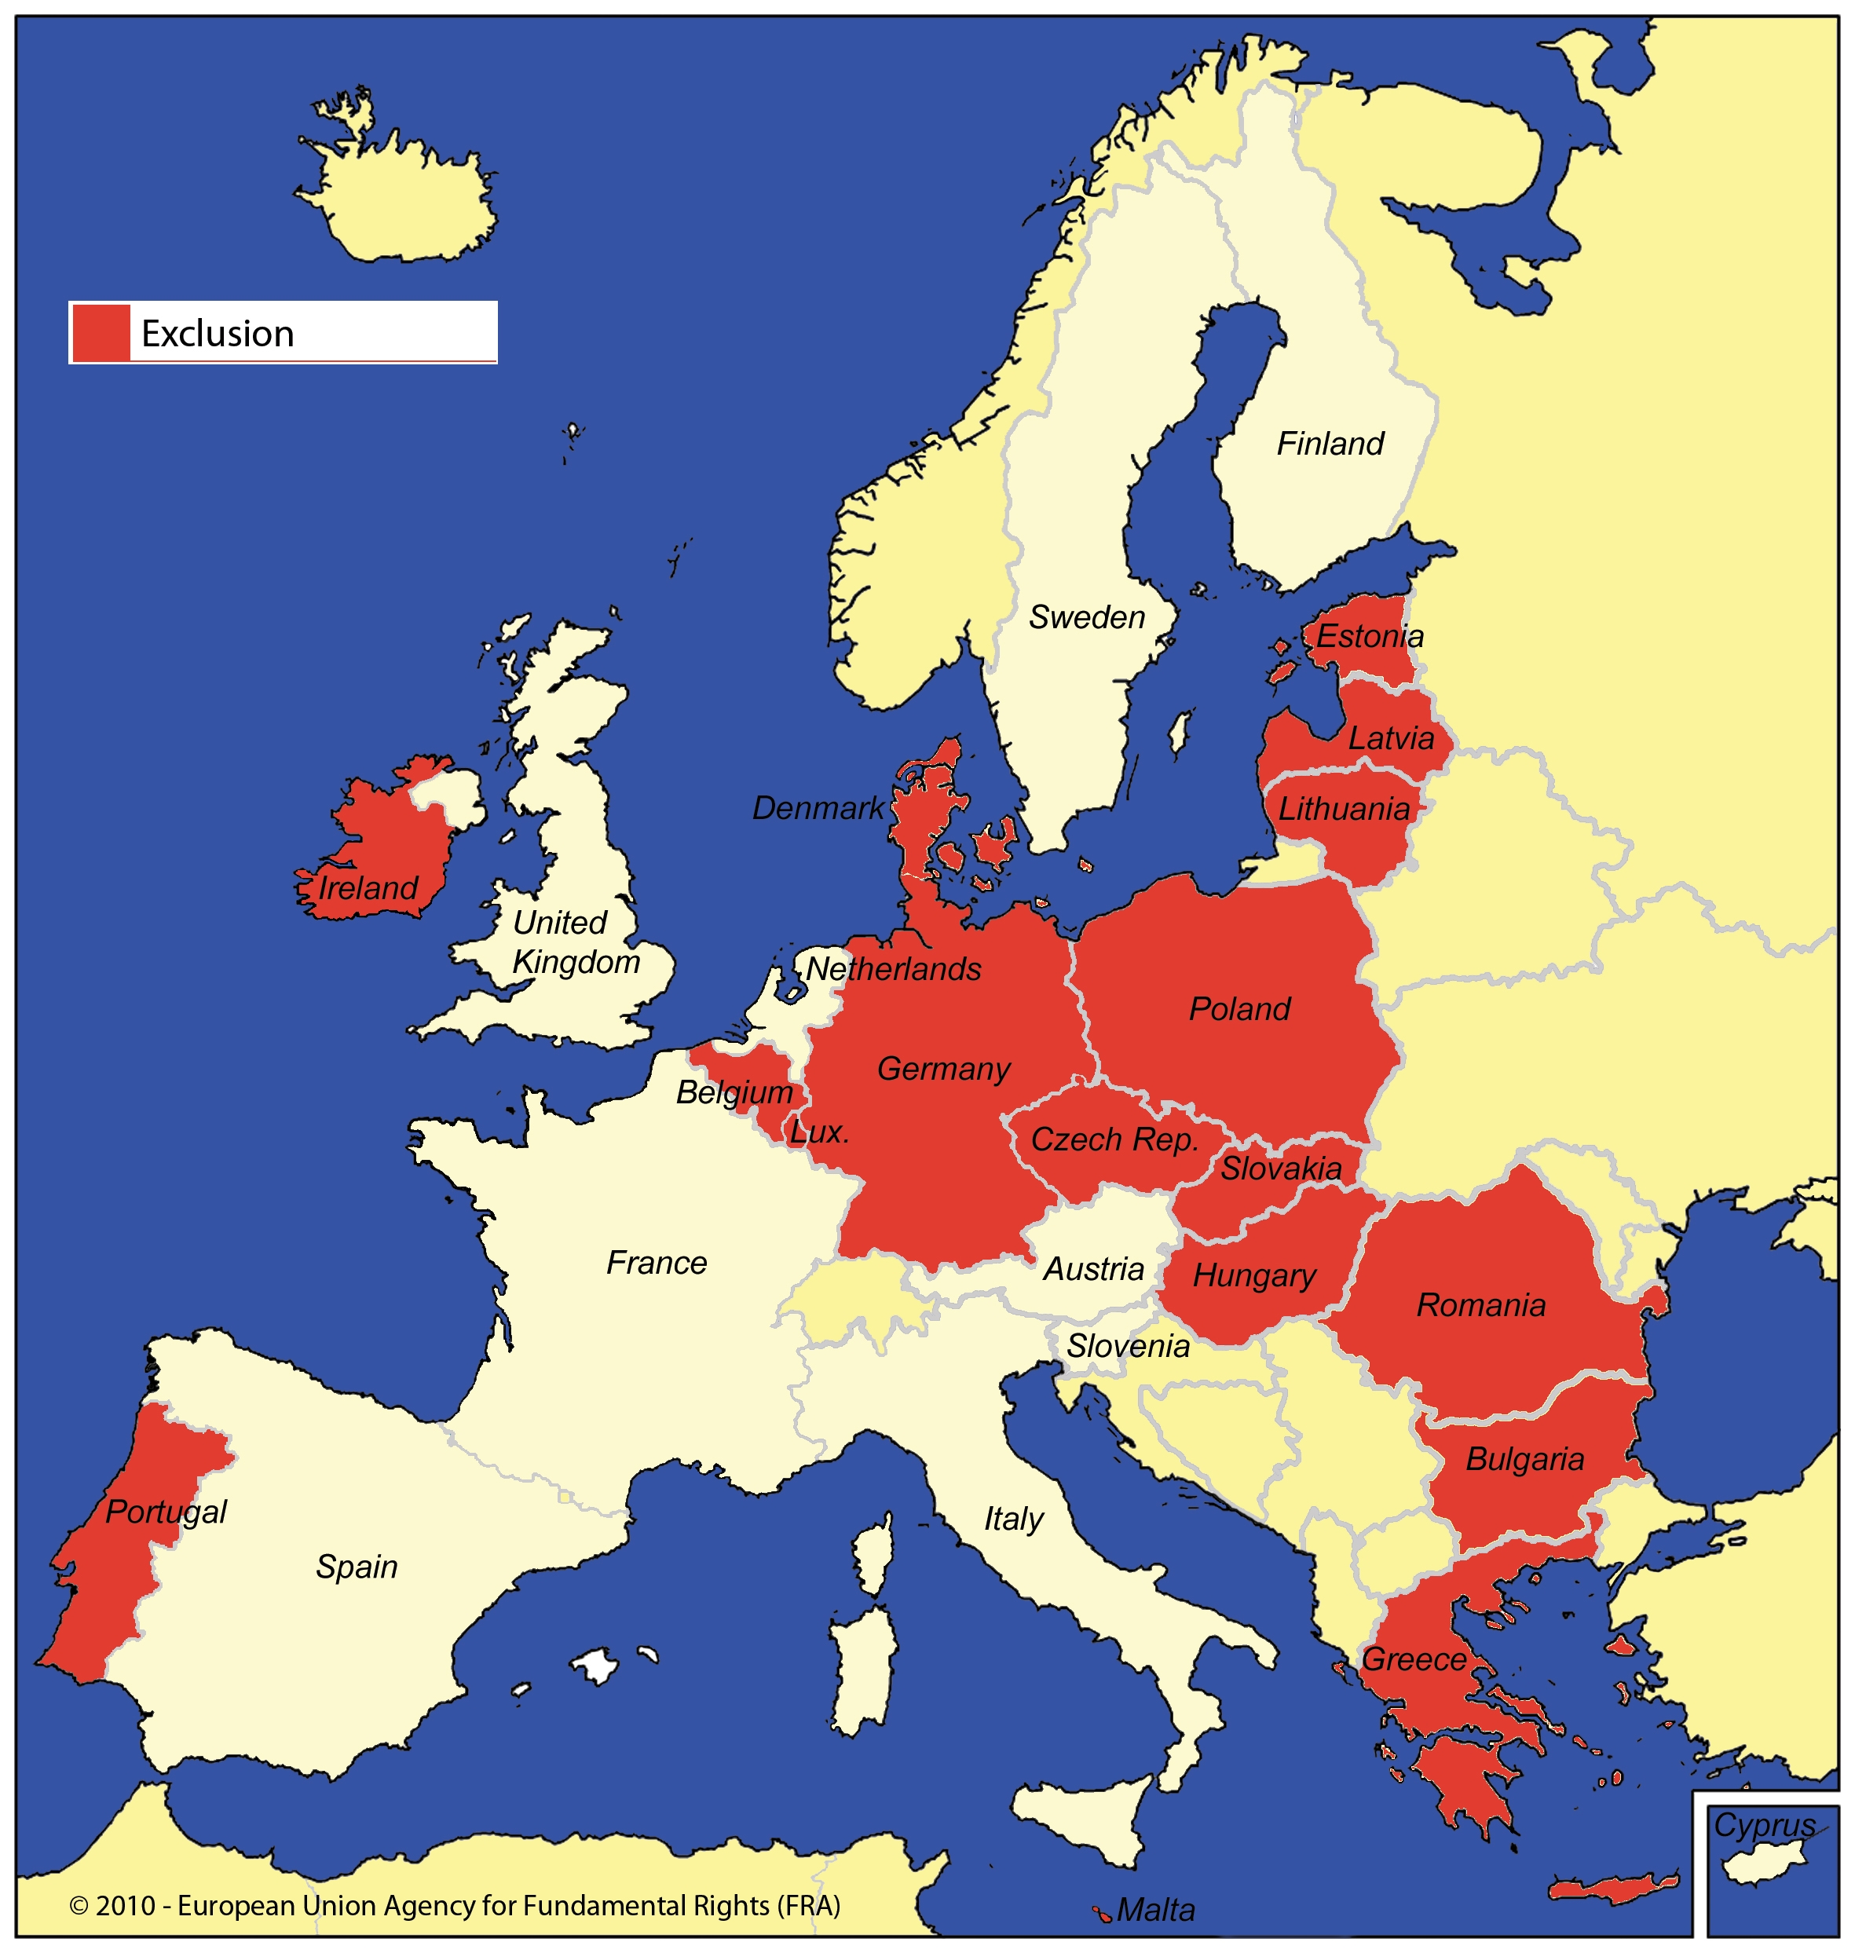
Notes: A country can be represented in more that one maps, as persons with mental health problems and persons with intellectual disabilities can be treated differently.
Source: FRA, 2010

In countries where there is an automatic exclusion it is either entrenched in the Constitution or prescribed in electoral legislation.
One example is Bulgaria where exclusion from political participation is triggered by deprivation of legal capacity. Article 42 (1) of the Bulgarian Constitution states: “Every citizen above the age of 18, with the exception of those placed under judicial interdiction (…), shall be free to elect state and local authorities and vote in referendums”. Persons with mental health problems and persons with intellectual disabilities who are considered not to be able to take care of their affairs and for that reason are placed under guardianship (“through judicial interdiction”) are thus deprived of their legal capacity. In other words, political rights are denied to all people under partial and plenary guardianship, regardless of their actual individual level of functional ability. In addition, the Political Parties Act provides that political parties can only be established by Bulgarian citizens who have the right to vote. Consequently, the exclusion of the right to vote for people under guardianship also leads to a ban on any other political activities.
The Hungarian Constitution provides an explicit exception from the universal right to vote – only persons with full legal capacity can exercise it. Persons placed under full or partial guardianship, even if in an unrelated area (such as parental rights, or consent to medical treatment), are excluded from political participation.
Similar constitutional provisions can be found in several countries: Czech Republic, Denmark, Estonia, Greece, Lithuania, Luxembourg, Malta or Poland, Portugal, among others.
In some other countries specific laws can have the effect of excluding certain categories of persons from the electoral process. The German Federal Electoral Law is an example of this approach. Persons for whom a custodian to manage all their affairs is appointed, not just by temporary order, are automatically deprived of their voting right.
The Lithuanian legal framework takes a similar approach: all relevant electoral legislation for presidential, parliamentary, municipal or European Parliament elections proscribes voting by persons who have been declared incapable by a court order.
Similar provisions are prescribed by law in other countries, including: Belgium, the Czech Republic, Denmark, Latvia, Portugal, Romania and Slovakia.
The next section will analyse the situation where the participation of persons with mental health problems and persons with intellectual disabilities is made possible, but in a limited way.
  - Limited political participation
These Member States (see Map 2) have adopted a variety of practices falling between the two ends of the spectrum, in which an assessment is made of the individual’s actual ability to vote. This individualised decision triggers our classification since, in some cases, these countries have adopted either an exclusion policy coupled with an individualised assessment (e.g. Estonia and Malta) or a full participation policy complemented with a specific decision on voting capacity (Spain and France). Furthermore, among these countries a differentiation can be made between those in which the individual’s situation is assessed by a medical practitioner and those in which the assessment is made by a judge.
Map 2: Limited political participation in the European Union
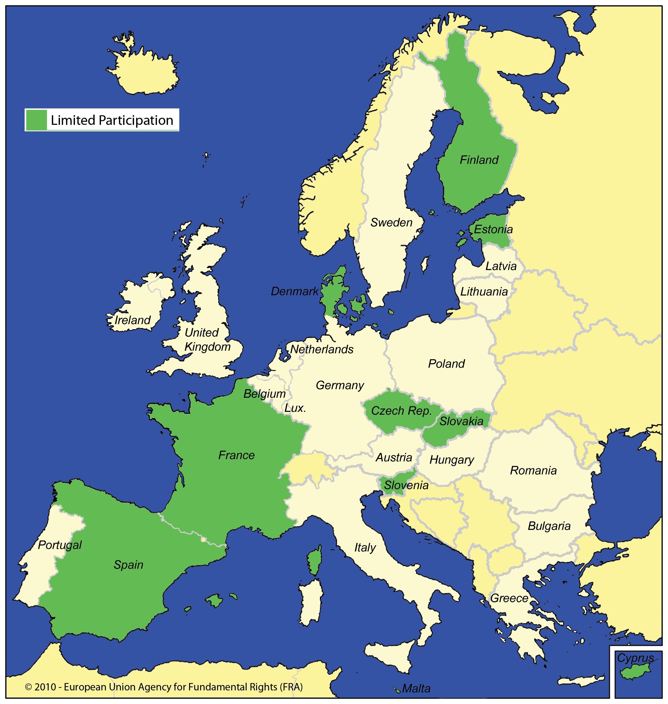
Notes: A country can be represented in more that one maps, as persons with mental health problems and persons with intellectual disabilities can be treated differently.
Source: FRA, 2010
In the case of Cyprus, it appears that disenfranchisement procedures foreseen by law are no longer being applied in practice. Therefore, persons with intellectual disabilities and persons with mental health problems who could, by law, be struck off the voters’ lists are not being removed. However, in the case of a person placed in a psychiatric institution, it is up to the treating psychiatrist to decide whether a patient will be able to exercise his or her right to vote. A patient will regain his or her political rights after discharge from the institution. There is currently a debate as to whether even during involuntary placement patients could still retain some of those rights.
As mentioned in the previous section, the constitution of Malta denies voting rights to persons “interdicted or incapacitated for any mental infirmity by a court in Malta or (…) otherwise determined in Malta to be of unsound mind”. A medical board, consisting of doctors, is set up to decide on any dispute related to the exclusion of persons “with mental infirmity” or persons with “unsound mind” as foreseen in the constitution. Unless a competent court takes a decision concerning the incapacity of an individual, the medical board’s decision will be needed before refusing to register a person as a voter.
In Estonia, as mentioned in the previous section, the constitution foresees an exclusion of the right to vote for persons deprived of their legal capacity. Nevertheless, according to the Code of Civil Procedure, a person whose legal capacity would only be partially limited by a court could still retain his or her right to vote.
France and Spain have similar laws. In 2007, the French legislature amended the Electoral Code: when deciding to maintain or renew a protective measure, the judge will decide whether to maintain or not the right to vote of the individual. Likewise in Spain, the express restriction of the right to vote needs to be decided upon by a judge according to the Act on the General Electoral System.
The situation in the Czech Republic appears to be evolving in a similar direction. Although in principle the right to vote is closely linked to the legal capacity of an individual, in fact incapable individuals enjoy neither the active nor the passive right to vote. In 2009, the Constitutional Court held that only in case of total legal incapacity should an individual be deprived of his or her right to vote. If an individual’s capacity is merely limited, all the circumstances of the case have to be considered to determine if she/he enjoys the right to vote as well as other political rights. In the present case, the Court decided that a slight “mental retardation” (to use the terms of the Court) should not deprive the particular individual of her right to vote. In a 2010 decision, the Constitutional Court stated that, even in proceedings aimed at deprivation of legal capacity, courts should perform a personal assessment in order to judge whether an individual who is about to loose his or her legal capacity can in fact participate in the election process. In that case, the person’s legal capacity should only be limited and not fully deprive of his or her legal capacity.
The situation in Slovenia is somewhat particular. National legislation used to proscribe participation in the electoral process by persons deprived of legal capacity. However, in 2003, the Slovenian Constitutional Court found the relevant provisions unconstitutional. According to the Court, capacity to vote should not be equated with legal capacity. Parliament amended the legislation in 2006. According to the amended Act, in order to restrict the right to vote of an individual, a court needs 1) to decide on the prolongation of parental rights, which in Slovenia is a specific form of guardianship, and 2) to confirm that the individual is unable to understand the meaning, purpose and effect of the elections.
The final section of this comparative analysis will describe the situation in countries that have lifted all restrictions on political participation by persons with intellectual disabilities and persons with mental health problems.
  - Full political participation
A minority of countries has lifted all restrictions on political participation; in doing so, these countries have opted to give persons with mental health problems and persons with intellectual disabilities full participation in the electoral process (see Map 3).
Map 3: Full political participation in the European Union
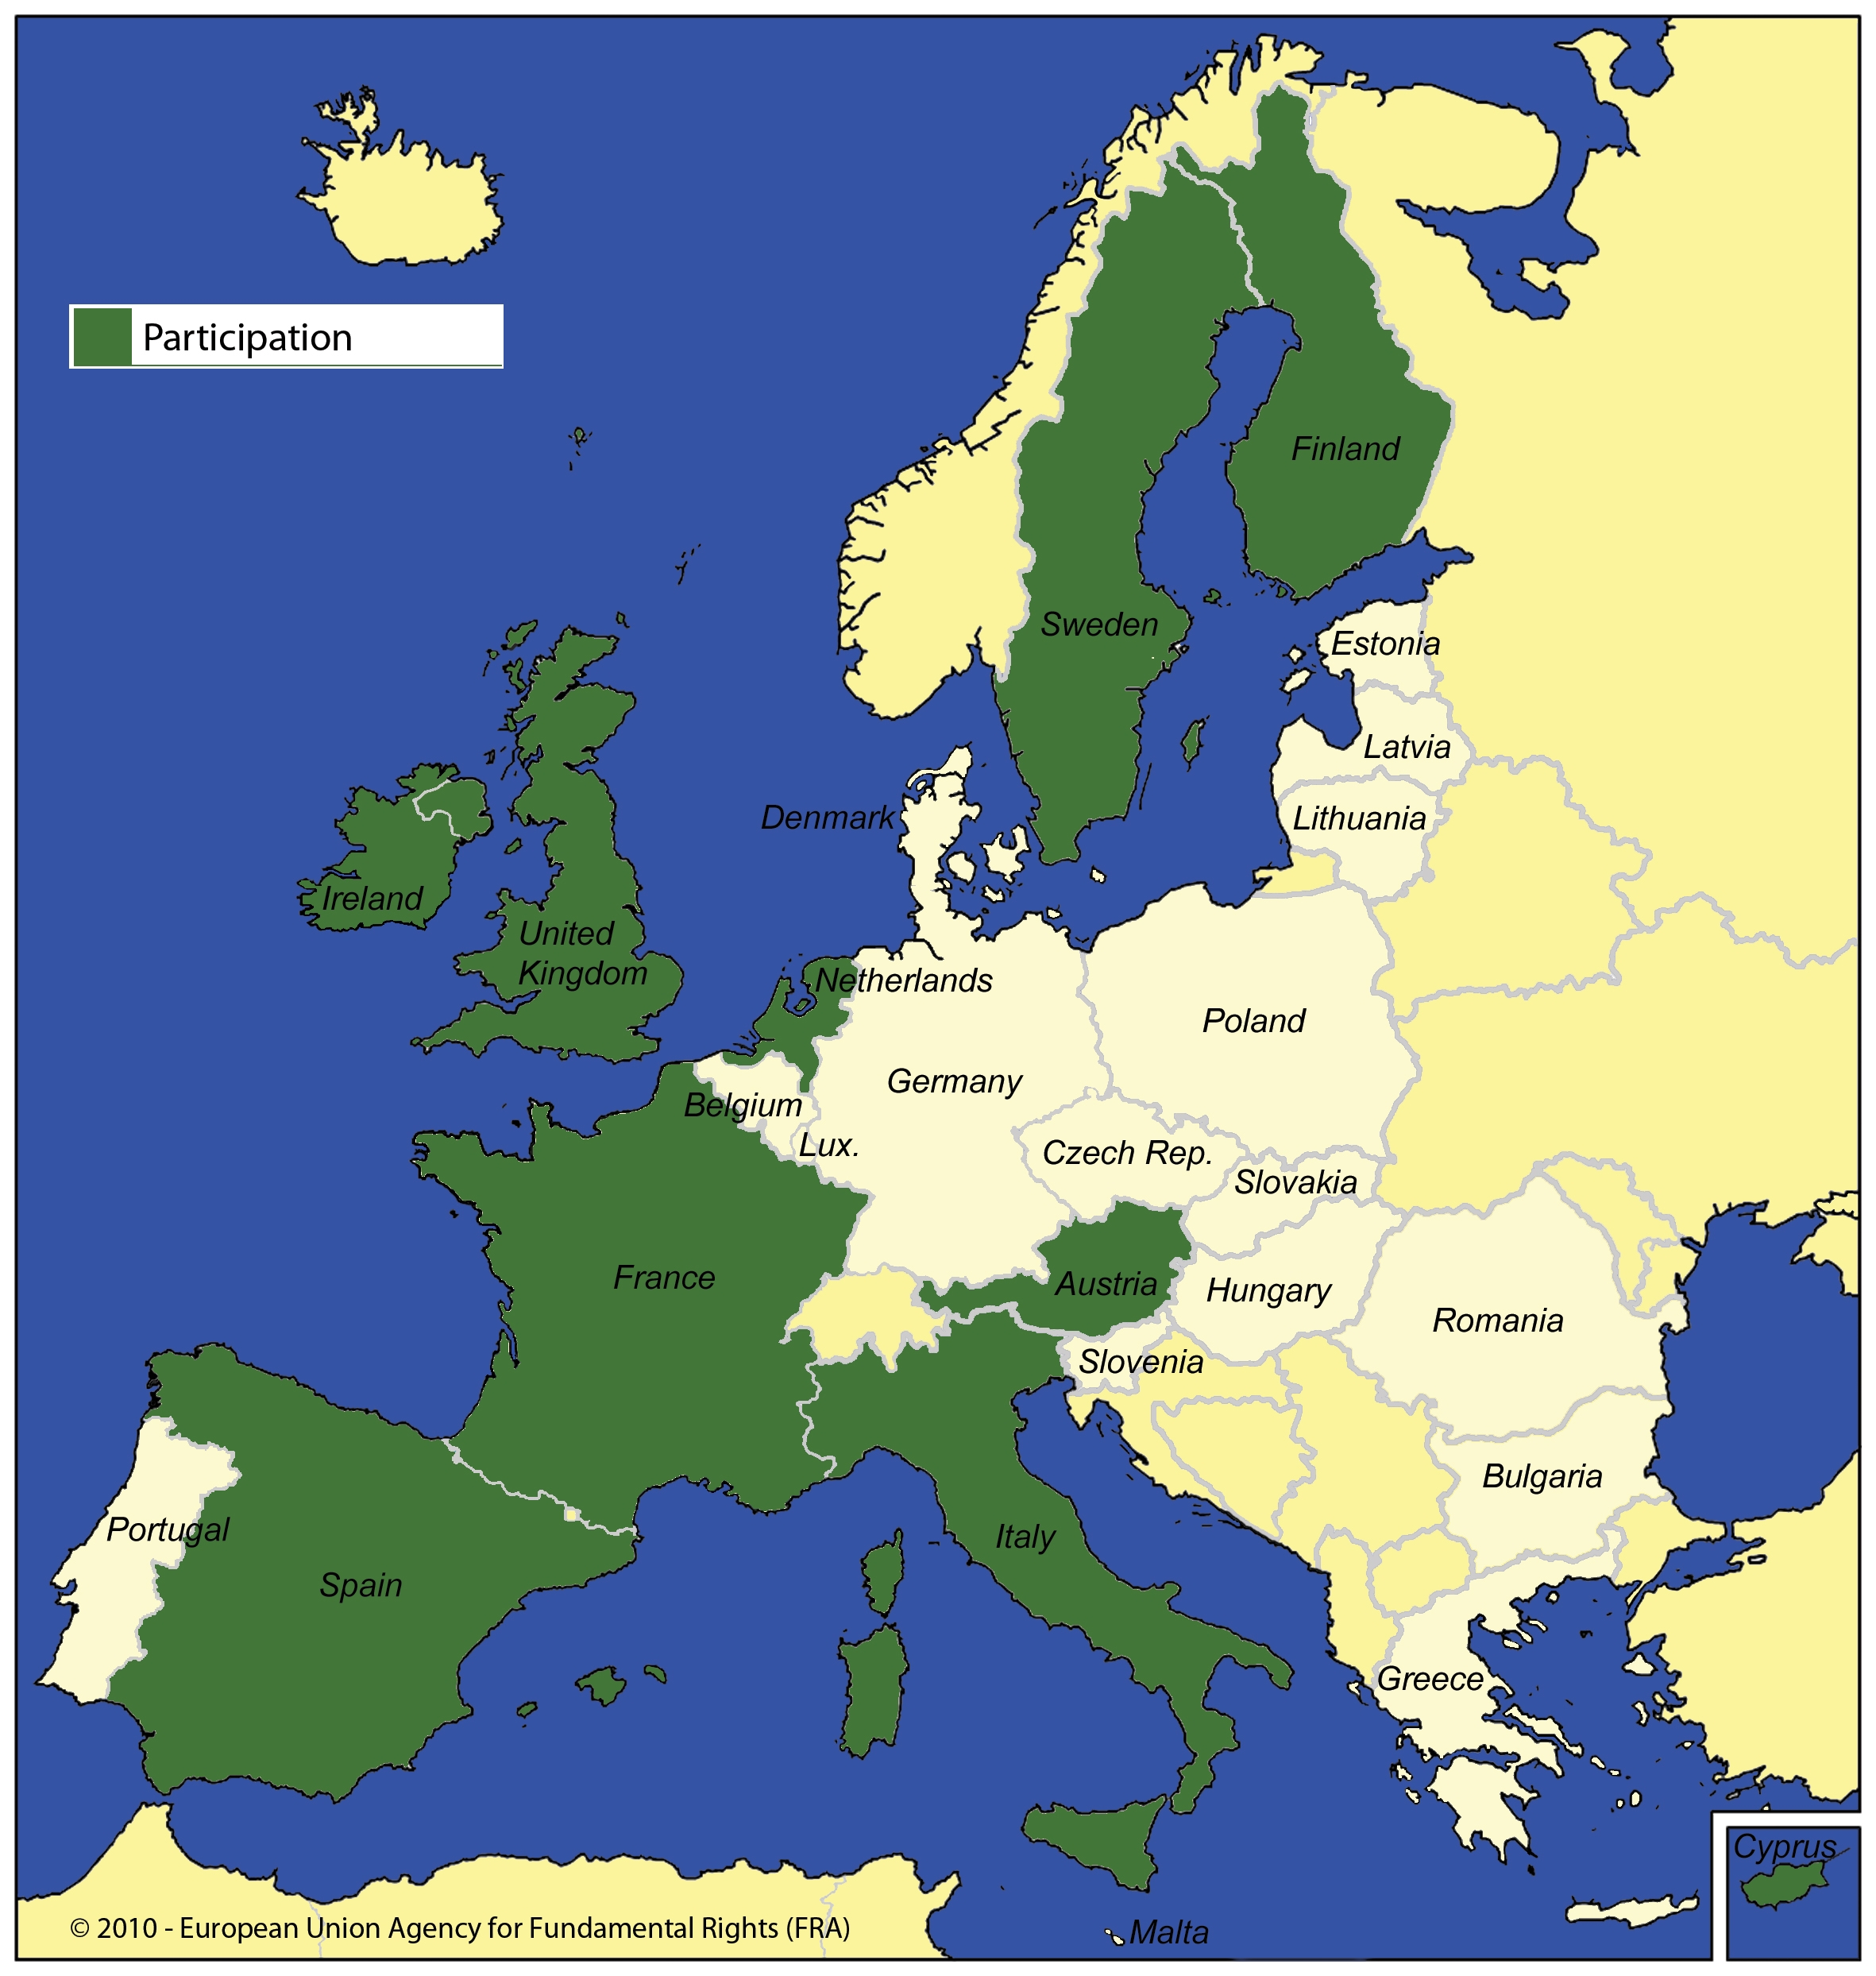
A country can be represented in more that one maps, as persons with mental health problems and persons with intellectual disabilities can be treated differently.
Source: FRA, 2010
In several countries, the right to full participation is entrenched in national constitutions. This is the case specifically in Austria, Finland, The Netherlands, Spain and Sweden.
Austria is one of the states in which persons with mental health problems and persons with intellectual disabilities are allowed to vote and to be elected like all other citizens. According to Article 26(5) of the Austrian Constitution, a person can only be deprived of his or her right to vote and to be elected in case of a criminal conviction, which is further specified in Section 22 of the Elections to the Parliament Act.
The Netherlands has also opted for a no exclusion policy. The 1983 constitutional text provided that persons who, because of their mental health problems or intellectual disabilities, were placed under custodial care could not exercise their right to vote (Article 54 (2) of the Constitution). In 2003, the Administrative Jurisdiction Department of the Council of State held that this general exclusion provision was in violation of the International Covenant on Civil and Political Rights. Following this decision and the advice of the Electoral Council, in 2008 the Constitution was amended and the provision was repealed. As a result of this constitutional revision, individuals with mental health problems and persons with intellectual disabilities can now enjoy the right to vote. This change has applied since the elections for the European Parliament on 4 June 2009.
In Italy, electoral law was used to deprive of their right to vote persons placed in psychiatric hospitals and persons subject to capacity limitations. However, these rules were repealed by the so-called Basaglia Law. Consequently, no limitation presently applies to the right to vote of persons with intellectual disabilities and persons with mental health problems.
In the United Kingdom, the Electoral Administration Act 2006 abolished the common law rule that a person lacks legal capacity to vote by reason of mental health problems.
- The way forward
The above discussion began by recalling the international and European standards favouring the full participation of persons with intellectual disabilities and persons with mental health problems in the electoral process. The comparative law analysis then highlighted the diverse approaches adopted in the European Union Member States. In a majority of these, persons who have lost their legal capacity are automatically deprived of their right to political participation. The European Court of Human Rights however clearly stated that such an automatic deprivation contravenes the European Convention on Human Rights. The practice in other countries is to organise an individualised assessment of the actual ability to vote of the individuals in question. Finally, a third group of countries have moved towards full participation of persons with disabilities in the electoral process. Against this background, what is the way forward?
The guiding principles should be clearly drawn from Article 29 CRPD. This was recently reaffirmed in Resolution 1642 (2009) of the Parliamentary Assembly of the Council of Europe on Access to rights for people with disabilities and their full and active participation in society. The parliamentarians urged Council of Europe Member States to take necessary measures “to ensure that, in accordance with the United Nations Convention on the Rights of Persons with Disabilities and its Optional Protocol, people placed under guardianship are not deprived of their fundamental rights (not least the rights to own property, to work, to a family life, to marry, to vote, to form and join associations, to bring legal proceedings and to draw up a will) and, where they need external assistance so as to exercise those rights, that they are afforded appropriate support, without their wishes or intentions being superseded”.
In fact, in its General Comment on Article 25 ICCPR of 1996, the Human Rights Committee already suggested, somewhat cautiously, this approach. It noted that “positive measures should be taken to overcome specific difficulties, such as illiteracy [or] language barriers (…) which prevent persons entitled to vote from exercising their rights effectively. Information and materials about voting should be available in minority languages. Specific methods, such as photographs and symbols, should be adopted to ensure that illiterate voters have adequate information on which to base their choice.” The same argument could be used for persons with disabilities. It would seem that restrictions on voting rights of persons with disabilities should only be allowed in circumstances where no measures could be taken that would accommodate their specific needs in order to allow them to take part in the election. Measures that could be taken include: the provision of clear explanations throughout the electoral process; usage of simple language and sentences accompanied by illustrations; ensuring that funding is available for the provision of accessible information throughout the electoral process; allowing persons with disabilities to choose a person of their choice to serve as personal assistant throughout the voting procedure (as specifically suggested by Article 29 (i, a) CRPD); encouraging each political party to describe their programme in similarly formatted and easy to read language; electoral process information sessions in specialised institutions; training of people in charge of supervising the elections at the local level in order to ensure that they can provide appropriate explanations about the procedure for persons with mental health problems and persons with intellectual disabilities; ensuring that accessibility measures are implemented for any future technological developments such as electronic voting.
The Council of Europe Disability Action Plan 2006-2015 in its Action Line No. 1 on participation in political and public life contains 4 specific objectives that Member States should reach with the help of 8 specific actions that they should carry out.
These adaptations to the particular needs of persons with disabilities are taking place in a number of countries. To take just few examples: in Denmark, persons with mental heath problems or intellectual disabilities who are allowed to vote can receive assistance when doing so. The Act on Parliament Elections, the Act on Election of Danish Members to the European Parliament and the Act on Municipality and Regional Elections were all recently amended so that all persons with disabilities have the right to designate a person of their own choice to assist them when voting. It follows that in each of the three legislations a provision was introduced according to which two returning officers or polling officials are designated to help the person with a disability to vote. The voter can also choose to receive assistance by a person of his or her own choice under the supervision of the electoral officials. In the United Kingdom, the Representation of the People Act 2000 gives all electors suffering from blindness, physical incapacity or incapacity to read (which would encompass a number of people with intellectual disabilities) the right to vote with the assistance of a companion. The Electoral Administration Act 2006 contains provisions requiring local authorities to review access to voting stations for all persons, including those with disabilities. Against this background, easy-to-read guides have been produced to inform people with intellectual disabilities about how to vote. For the last general election 2010, the main political parties provided their party manifestos in easy-to-read language.
The Council of Europe Committee of experts on participation of people with disabilities in political and public life (CAHPAH-PPL) is preparing a report taking stock of consultative and participatory mechanisms aimed at enhancing the participation of people with disabilities in political and public life in Council of Europe Member States. The report will provide examples of good practice and innovative experiences. Based on its findings, CAHPAH-PPL will elaborate recommendations for Member States to actively promote the participation in political life of persons with disabilities.
In conclusion, this brief report suggests some States Parties will need to amend their relevant legislation to meet the standards of the CRPD. These changes will need to take into account the specific needs of persons with disabilities. Involving these persons or their representative organisations in the design and implementation of new legislation and accompanying measures would not only be in the spirit of the CRPD, but would also be essential in finding practical and effective solutions. To this end, the second component of the FRA study on the fundamental rights of persons with mental health problems and persons with intellectual disabilities incorporates the engagement of these persons in data collection in 8 EU Member States to better understand their enjoyment and limitations of their rights in practice.

*****

In addition to the current report, the FRA will publish the following short comparative law reports in the context of its project on the ‘Fundamental rights of persons with mental health problems and persons with intellectual disabilities’:
- Involuntary placement and involuntary treatment
- Legal capacity

Annex
Countries | Exclusion | Limited Participation | Participation
AUSTRIA |  |  | Article 26 Constitution of Austria
BELGIUM | Article 7 1° Electoral Code
BULGARIA | Article 42 (1) Constitution of Bulgaria
CYPRUS |  |  | Article 31 Constitution of the Republic of Cyprus
CZECH REPUBLIC | Article 2 of Elections to the Parliament of the Czech Republic Act 247/1995  Article 10 Civil Code  Article 855 Civil Code | Article 10 Civil Code  Article 855 Civil Code
DENMARK | Section 29 (1) Constitutional Act of Denmark | Section49 (1) and (4) Parliamentary Election Act
ESTONIA | Article 57 Constitution of the Republic of Estonia  Article 5 (3) Local Government Council Election Act | Article 526 (5) Code of Civil Procedure
FINLAND |  | Section 27 Constitution of Finland | Section 14 Constitution  Section 2 Election Act
FRANCE |  | Article L5 Electoral Code | Article L3211-3 6) Public Health Code
GERMANY | Article 13 Federal Election Act
GREECE | Article 51 (3) Constitution of Greece  Article 5 Presidential Decree 96/2007
HUNGARY | Article 70 (5) Constitution of the Republic of Hungary
IRELAND | Lunacy Regulation (Ireland) Act 1871 and Order 67 of the Rules of the Superior Courts 1986 |  | Article 7(1) Electoral Act of Ireland 1992
ITALY |  |  | Article 11 Law 180/1978
LATVIA | Article 2 (3) Saeima Election Law
LITHUANIA | Article 34 (3) Constitution of the Republic of Lithuania
LUXEMBOURG | Article 53 (1) 3 Constitution of the Grand Duchy of Luxembourg  Article 6 -3° Election Law 2003
MALTA | Article 58 (a) Constitution of Malta | Section 13 (9) and Section 27 (3) General Elections Act
NETHERLANDS |  |  | Article 54 -2 Constitution of the Netherlands
POLAND | Article 62-2 Constitution of Poland
PORTUGAL | Article 49 (1) Constitution of the Republic of Portugal  Article 2 Parliamentary electoral law
ROMANIA | Art. 36 -2 Constitution of Romania
SLOVAKIA | Section 2 (2) c) Law of the Narional Council  Section 2-3 Act of the Slovak Republic on European Parliamentary Elections 2003
SLOVENIA |  | Article 7 National Assembly Elections Act 2006
SPAIN |  | Article 3. 1. b)-c) Law on Regime of General Elections | Art. 23 Constitution of Spain
SWEDEN |  |  | Chapter 1 Article 1 Constitution of Sweden - The instrument of Government  Chapter 3 Article 2 Constitution of Sweden - The instrument of Government
UNITED KINGDOM |  |  | C2 section 13-39 Electoral Administration Act 2006  C22 section 73 Electoral Administration Act 2006

This report provides the first results from a legal study carried out by the European Union Agency for Fundamental Rights (FRA) in the context of its project on the ‘Fundamental rights of persons with intellectual disabilities and persons with mental health problems’. Given that the right to political participation is one of the fundamental rights of EU citizens, the FRA decided to publish its findings in this area. The report sets out by recalling the international and European standards favouring the full participation of persons with intellectual disabilities and persons with mental health problems in the electoral process. The comparative law analysis then highlights the diverse approaches adopted in the EU Member States. In a majority of these, persons who have lost their legal capacity are automatically deprived of their right to political participation. The European Court of Human Rights, however, clearly stated that such an automatic deprivation contravenes the European Convention on Human Rights, to which all EU Member States are party. In other EU Member States, the practice is to organise an individualised assessment of the actual ability to vote of the individuals in question. Finally, a third group of EU Member States have moved towards full participation of persons with disabilities in the electoral process. The report provides some way forward to make sure that the standards in this area are applied in practice.

See for additional information on this specific project: http://www.fra.europa.eu.
ECtHR, Alajos Kiss v. Hungary, No. 38832/06, judgment of 20 May 2010, paragraph 42.
Inclusion Europe and Mental Health Europe, The Difference between Mental Illness and Intellectual Disability (2004), available at http://www.inclusion-europe.org and http://www.mhe-sme.org.
See in particular the project ‘Accommodating Diversity for Active Participation in European Elections’ (ADAP); http://www.voting-for-all.eu/.
See the historical background of Article 25 ICCPR, Nowak, UN Covenant on Civil and Political Rights – CCPR Commentary (2005), pp. 566 ff.
Human Rights Committee, General Comment No. 25: ‘The right to participate in public affairs, voting rights and the right of equal access to public service (Article 25)’, UN doc. CCPR/C/21/Rev.1/Add.7 (12 July 1996), paragraph 4.
Ibid., paragraph 3.
Ibid., paragraph 10.
Ibid., paragraph 4.
See Harris, O’Boyle and Warbrick, Law of the European Convention on Human Rights, 2nd Ed. (2009), p. 712.
ECtHR, Mathieu- Mohin and Clerfayt v. Belgium, No. 9267/81, judgment of 2 March 1987, paragraph 46-51
ECtHR, Hirst v. the United Kingdom No. 2 (GC), No. 74025/01, judgment of 6 October 2005, paragraph 58.
ECtHR, Hirst v. the United Kingdom No. 2, paragraphs 59 and 62.
See ECtHR, Mathieu- Mohin and Clerfayt v. Belgium, paragraph 52.
See Harris, O’Boyle and Warbrick, Law of the European Convention on Human Rights, 2nd Ed. (2009), p. 714.
See for case-law references, Harris, O’Boyle and Warbrick, Law of the European Convention on Human Rights, 2nd ed. (2009), pp. 730 ff.
ECtHR, Matthews v. the United Kingdom (GC), No. 24833/94, judgment of 18 February 1999.
Article 10 TEU states: 1. The functioning of the Union shall be founded on representative democracy. 2. Citizens are directly represented at Union level in the European Parliament. (…) Article 22 TFEU states: 1. Every citizen of the Union residing in a Member State of which he is not a national shall have the right to vote and to stand as a candidate at municipal elections in the Member State in which he resides, under the same conditions as nationals of that State. This right shall be exercised subject to detailed arrangements adopted by the Council, acting unanimously in accordance with a special legislative procedure and after consulting the European Parliament; these arrangements may provide for derogations where warranted by problems specific to a Member State. 2. Without prejudice to Article 223(1) and to the provisions adopted for its implementation, every citizen of the Union residing in a Member State of which he is not a national shall have the right to vote and to stand as a candidate in elections to the European Parliament in the Member State in which he resides, under the same conditions as nationals of that State. This right shall be exercised subject to detailed arrangements adopted by the Council, acting unanimously in accordance with a special legislative procedure and after consulting the European Parliament; these arrangements may provide for derogations where warranted by problems specific to a Member State.
Council Directive 93/109/EC of 6 December 1993 laying down detailed arrangements for the exercise of the right to vote and stand as a candidate in elections to the European Parliament for citizens of the Union residing in a Member State of which they are not nationals, OJ L 329, 30.12.1993, pp. 34-38.
Council Directive 94/80/EC of 19 December 1994 laying down detailed arrangements for the exercise of the right to vote and to stand as a candidate in municipal elections by citizens of the Union residing in a Member State of which they are not nationals, OJ L 368, 31.12.1994, pp. 38-47.
See the latest adaptation: Council Directive 2006/106/EC of 20 November 2006, OJ L. 363 of 20.12.2006, pp. 409-410.
See the European Commission for Democracy through Law (the Venice Commission), Code of Good Practice in Electoral Matters – Guidelines and Explanatory Report, adopted by the Venice Commission at 52nd session (18-19 October 2002), Opinion No. 190/2002, doc. CDL-AD (2002) 23 rev.
Ibid., pp. 5-6.
G. Quinn, ‘A Short Guide to the United Nations Convention on the Rights of Persons with Disabilities’, 1 European Yearbook of Disability Law, 2009, p. 108.
Action line No.1: Participation in political and public life, Recommendation Rec(2006)5 of the Committee of Ministers to Member States on the Council of Europe Action Plan to promote the rights and full participation of people with disabilities in society: improving the quality of life of people with disabilities in Europe 2006-2015
Recommendation Rec(2004)10 of the Committee of Ministers to Member States concerning the protection of the human rights and dignity of persons with mental disorder.
Given its importance, the FRA will prepare a dedicated publication on this topic.
See Bartlett, Lewis, Thorold, Mental Disability and the European Convention on Human Rights, 2007, p. 196.
Recommendation R(99)4 of the Committee of Ministers to Member States on Principles Concerning the Legal Protection of Incapable Adults.
ECtHR, Alajos Kiss v. Hungary, No. 38832/06, judgment of 20 May 2010.
Ibid., paragraph 44.
Unofficial translation; see Venice Commission CODICES Database, available at: http:www.codices.coe.int.
See Article 93, paragraph2, Article 94 of the Constitution of the Republic of Bulgaria. By virtue of the fact that a person under guardianship is not eligible to be elected to the National Assembly, a person under guardianship is similarly disqualified from the Presidency and Vice-Presidency.
See Article 4 of the Political Parties Act.
See Article 70 (5) of the Constitution of Hungary.
See Article 13 (2) of the Federal Electoral Law.
See FRALEX thematic legal study on Cyprus.
See the website of Supervisory Committee for the Protection of the Rights of Mental Patients (or ‘Cyprus Mental Health Commission’) at: http://mentalhealthcommission.org.cy/en/law/ (03.06.2010).
Constitution of Malta, Article 58(a); http://docs.justice.gov.mt/lom/legislation/english/leg/vol_1/chapt0.pdf (03.06.2010).
Chapter 354 of the Laws of Malta, General Elections Act, Section 14(1); http://docs.justice.gov.mt/lom/legislation/english/leg/vol_9/chapt354.pdf (03.06.2010).
See Article 27 (1) of the General Elections Act.
See Article 526 (5) of the Code of Civil Procedure: http://www.legaltext.ee/text/en/x90041.htm (03.06.2010).
Article L 5 of the French Electoral Code: http://www.legifrance.gouv.fr/home.jsp (03.06.2010).
See Article 3.1. b) of the Act on the General Election System, Official State Journal no. 147 of 20.06.1985.
Act No. 247/1995 Coll., Election Act, Section 2.
Judgment of the Czech Constitutional Court I.ÚS 557/09 of 18.08.2009.
See Czech Constitutional Court, Decision No. IV. US 3102/08 of 21 July 2010 in the case of Soldán Jiří. Another case is pending before the Constitutional Court dealing with a similar issue: Hlaváč Tomáš (Case No. IV. US 3073/08). See in general the Amicus Curiae Brief co-ordinated by Mental Disability Advocacy Center (MDAC), available at: http://www.mdac.info/en/Czech-Republic (21 June 2010).
See Official Journal of the RS, No. 73/29 July 2003, pp. 11212-11216, cited in a Amicus Curiae Brief coordinated by MDAC, p. 19.
See Article 7(2) of the National Assembly Elections Act of 1992, as amended in 2006.
Austria/BGBl 471/1992 as amended by BGBl II 147/2008 (29.12.2008).
See Council of State decision of 29.10.2005, LJN AM5435.
See Article 2 (1) and Article 3 of the Presidential Decree n. 223/1967 (20.03.1967).
See Article 11 of Law No. 180/1978 of 13.05.1978.
Electoral Administration Act 2006 c.22, s73.
Adopted on 26 January 2009.
Human Rights Committee, General Comment No. 25: The right to participate in public affairs, voting rights and the right of equal access to public service (Article 25), UN doc. CCPR/C/21/Rev.1/Add.7 (12 July 1996), paragraph 12.
See Recommendation Rec(2006)5 of the Committee of Ministers of the Council of Europe on the Council of Europe Action Plan to promote the rights and full participation of people with disability in society: improving the quality of life of people with disabilities in Europe 2006-2015, adopted on 5 April 2006.
See Act no. 144 of 24.02.2009 on Municipality and Regional Elections, Act no. 145 of 24.02.2009 on Parliament Elections and Act no. 143 of 24.02.2009 on election of Danish Members to the European Parliament.
See Section 49 of the Act on Parliament Elections.
See Representation of the People Act 2000 c.2.
Representation of the People Act 2000 c.2, s13.
Electoral Administration Act 2006 c.22, s18 http://www.opsi.gov.uk/ACTS/acts2006/ukpga_20060022_en_1 (03.06.2010).
See http://www.dopolitics.org.uk.
See, for example: http://www.labour.org.uk/manifesto/accessible or http://www.conservatives.com/Policy/Manifesto.aspx.

