Together in the European Union

Together in the European Union
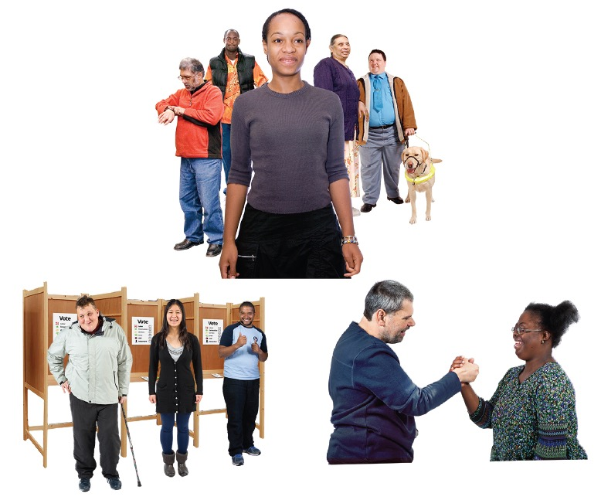

What is in this book
Inside this book you will read about:
 | Who wrote this book Page 4
 | What this book is about Page 5
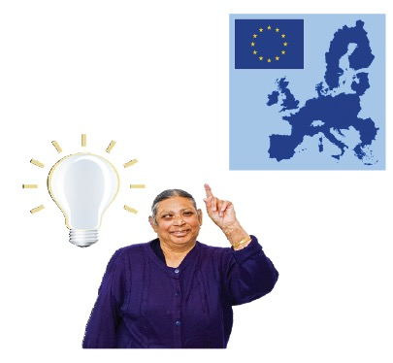 | How countries can help Page 7

Who wrote this book

We are the European Union Agency for Fundamental Rights.

We wrote this book.

We are called FRA for short.
We are an organisation.

An organisation is a group of people working together.
We help to make sure everyone
in the European Union
can use their rights.

The European Union is a group of 28 countries in Europe.
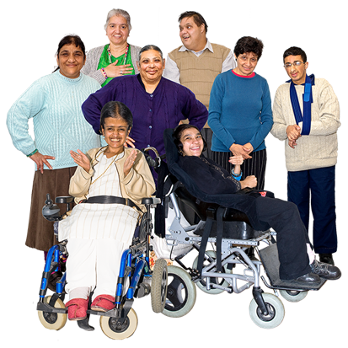 | Rights are things that everyone has.  They are what people get to do.

What this book is about
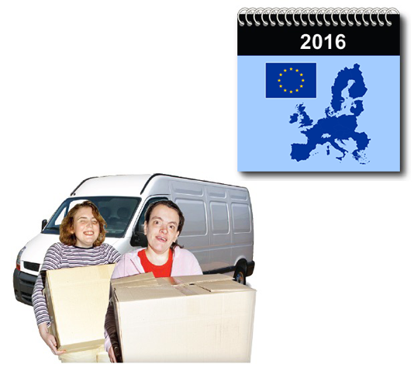 | More than 20 million immigrants lived in the European Union in 2016.
 | This means that 1 person in 25 was an immigrant.
 | An immigrant is a person who has moved to a different country and plans to stay there.
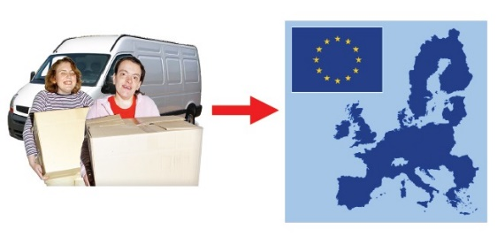 | In the past year a lot of immigrants and refugees have moved to the European Union.  A refugee is someone who has escaped their own country because they were in danger in their own country.
 | Countries in the European Union have different ways of helping to make immigrants feel at home.

How countries can help
We asked immigrants if they had felt discriminated against.

1 in 3 said yes.
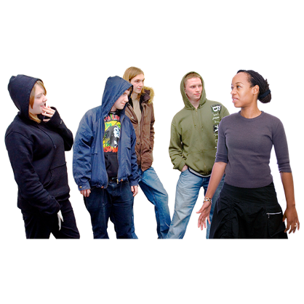 | Discrimination is treating people badly because they are different.  For example, this can be because of their skin colour or where they are from.
 | When young people are discriminated against, this can make them feel bad about themselves.
 | Discrimination also makes them more likely to be violent.
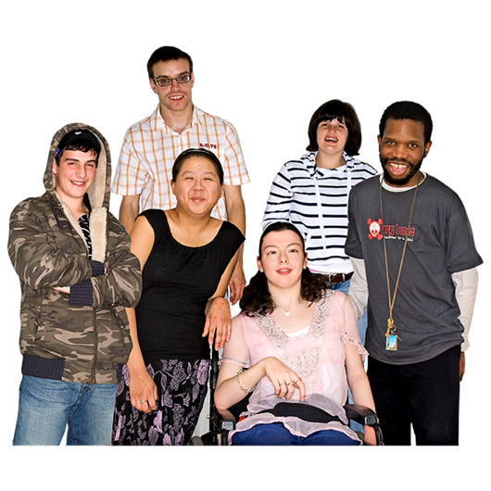 | Equality means treating everybody the same.
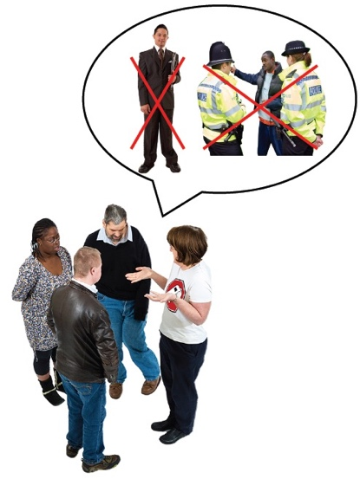 | Very few people tell organisations in charge of equality that people have discriminated against them.
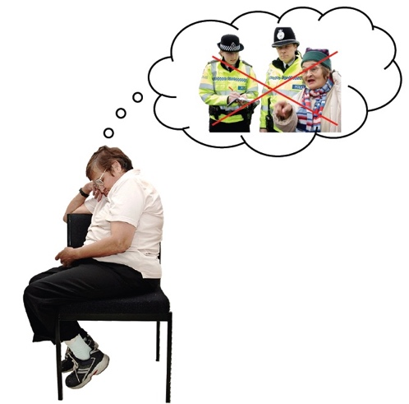 | This might be because they do not know their rights or because they mistrust the authorities.
 | An authority is a group of people who have to take care of you for certain things.
 | For example, the police are people who make sure that other people are treated equally.
Having more immigrants and refugees makes it even more important for the governments to have plans to help them to integrate.

Integration is when immigrants become part of the group of people who already live in that country.
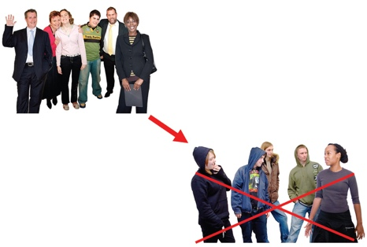 | More integration should mean less discrimination.
 | For integration to work, immigrants and local people need to work together.
Integration mainly happens locally.
For example, in schools, in sports clubs and at work.
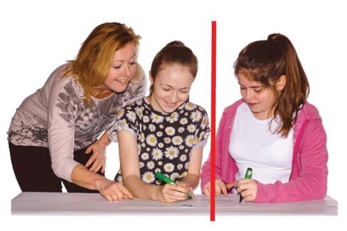 | Some schools segregate immigrant children.
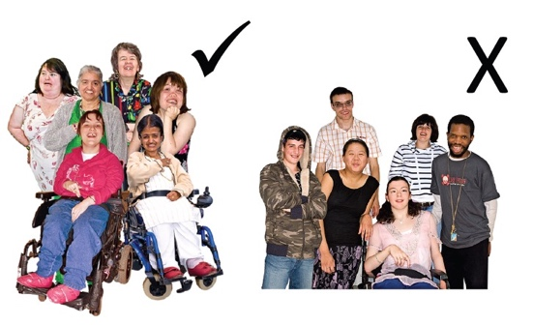 | Segregation is keeping one group of people apart from another group and treating them differently.  For example, because of their skin colour or where they are from.
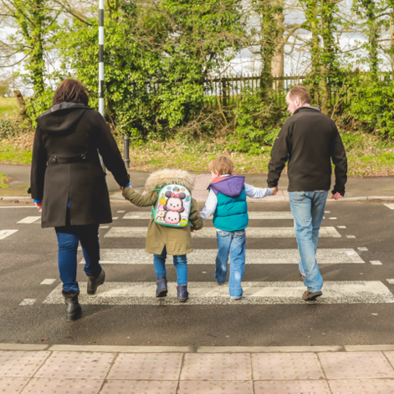 | Parents like to send their children to schools where other children are like them.
 | Schools should integrate people, because otherwise we could all end up living apart instead of together.
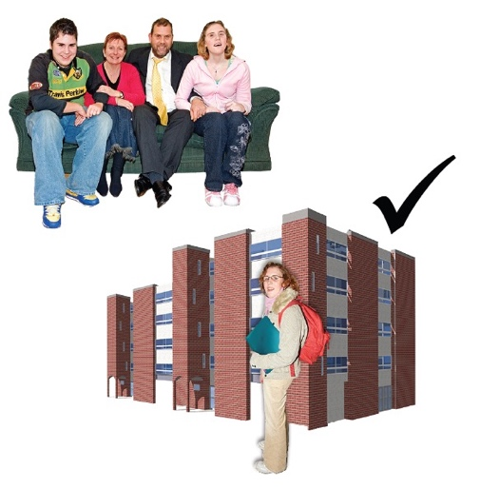 | Children whose parents are from the country where they live do better at school than children who are immigrants or who have immigrant parents.
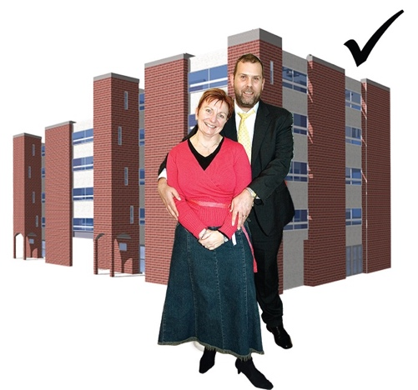 | We say that schools should encourage immigrant parents to get involved.
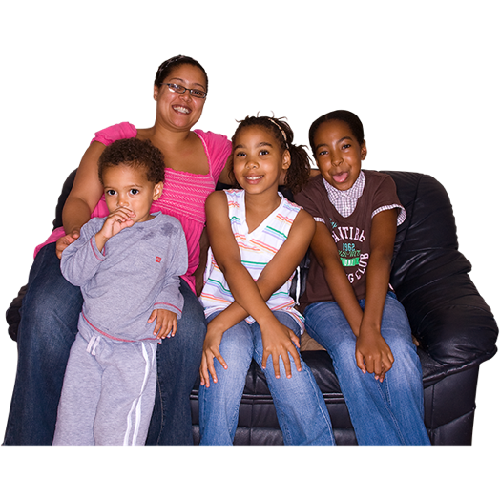 | When parents are involved, immigrant families will integrate into their communities better.
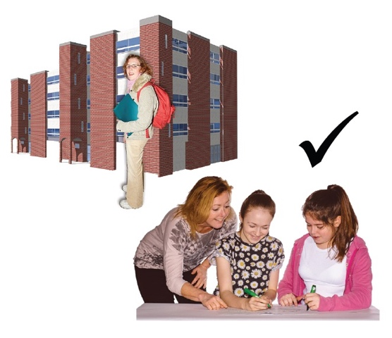 | As a result, the children will do better at school.
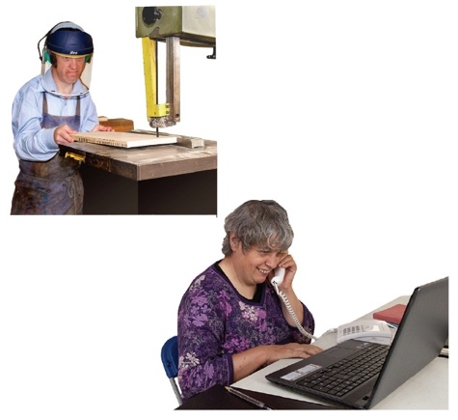 | Learning makes sure that immigrants have the skills that they need for their job.
 | Immigrants will also have more contact with people who come from where they live.
 | So, if immigrants get to learn, it is good for them and for everyone else.
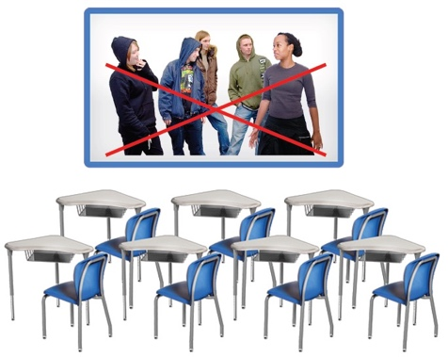 | We say that governments and schools need to agree that discrimination in education is an important problem.  They need to focus on fixing that problem.
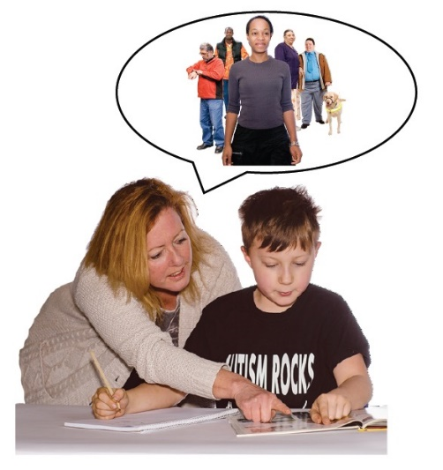 | We say that schools need to help students know about diversity.  Diversity means that people are different from you and from each other.
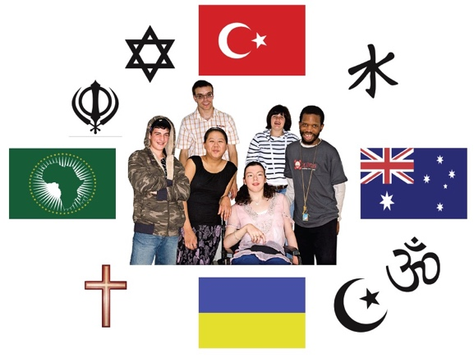 | Some people have different religions or different skin colours or come from different places.
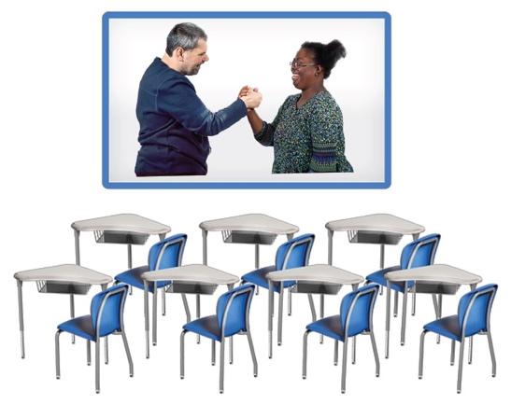 | Schools need to teach students to include other people.
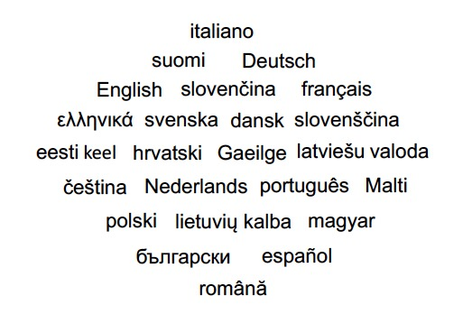 | Another important way to feel part of society is being able to speak the language.
 | We say that governments should make it easy for immigrants to learn the national language.
For example, they can make it free of charge.

They can give lessons during school hours to parents who do not have a job.
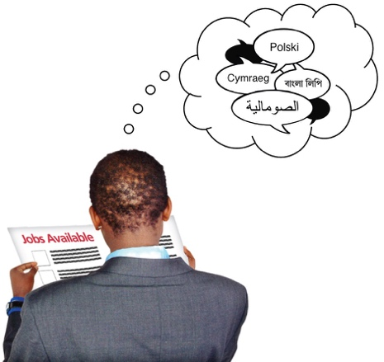 | If they learn the language, immigrants will be able to find work more easily.
 | Twice as many immigrant families are poor as families who are from the country where they live.
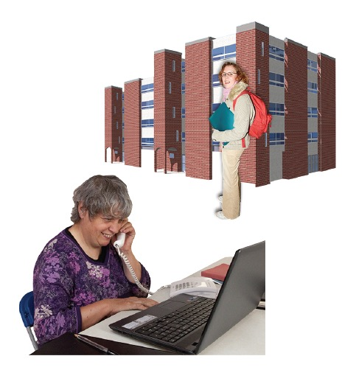 | Young people are more likely to have a job or go to school if their parents are from the country they live in than if their parents are immigrants.
 | We say that governments should tell employers that it would be good to hire people who are immigrants or whose parents are immigrants.
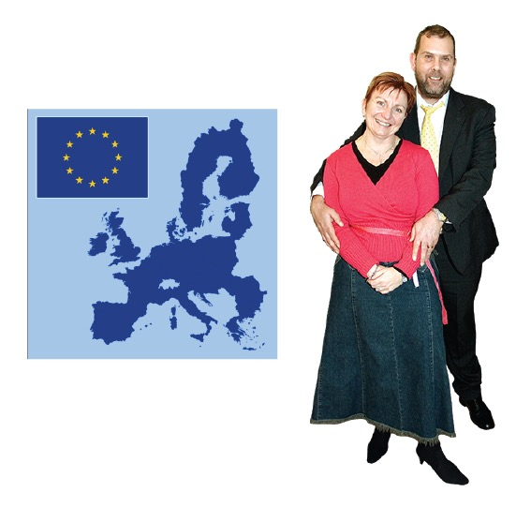 | In most countries of the European Union, immigrants and people whose parents are immigrants have as much chance as people from that country to find work in the public sector.
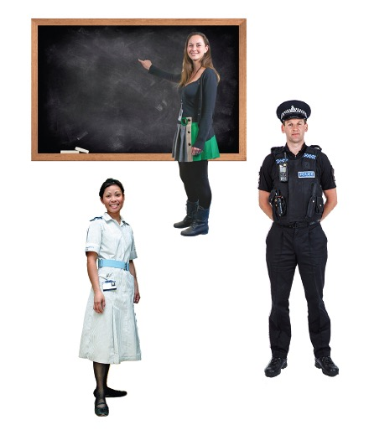 | Jobs in the public sector are controlled by the government.  Examples of people who work in the public sector are doctors, nurses, teachers and the police.
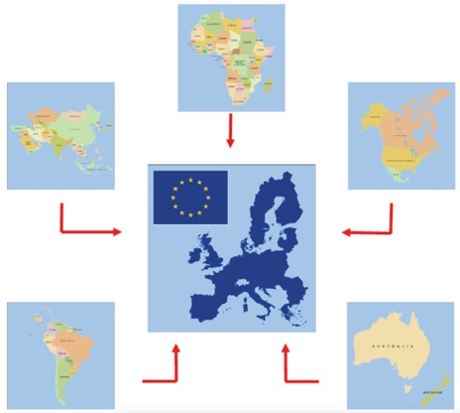 | Immigrants from outside the European Union have different political rights in different countries.
 | We say that immigrants should help make policies that affect them.
 | When immigrants are involved they will feel like they are part of society.
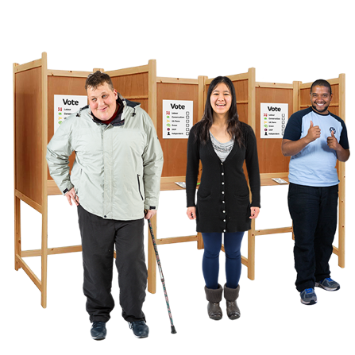 | We say that immigrants should be allowed to vote and join political parties.
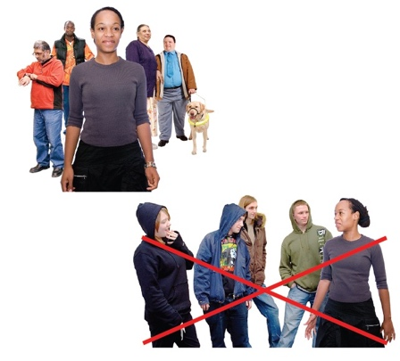 | We say that immigrants should be treated equally and people should not discriminate against them.
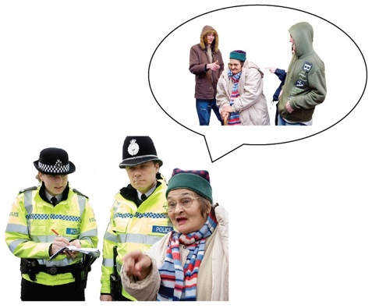 | We say that immigrants should feel comfortable telling the police when people discriminate against them.
 | We say that governments should help immigrants and local people understand each other, trust each other and do things together.

This book was developed thanks to the support of Mencap Liverpool.

