Human rights work in challenging times:
Ways forward
Report of the meeting of FRA’s Fundamental Rights Platform
1 February 2021

The 2021 Fundamental Rights Platform meeting 2021 looked at the resilience of civil society organisations, as well as the continued importance of defending human rights during these challenging times. The virtual event provided an opportunity for cooperation and information exchange between FRA and civil society organisations working on fundamental rights in the EU. With a focus on finding ways to overcome human rights challenges, the meeting also offered a platform for civil society organisations to learn from each other and to share policy recommendations with representatives of EU and international organisations. It brought together stakeholders involved in defending and advancing human rights from all corners of the EU.
Participants
All organisations registered in FRA’s Fundamental Rights Platform (FRP) database were invited, along with participants from EU institutions, intergovernmental organisations, and other international partners working with and/or providing funding to civil society. Over 300 people took part at different moments of the event. Why did they join?
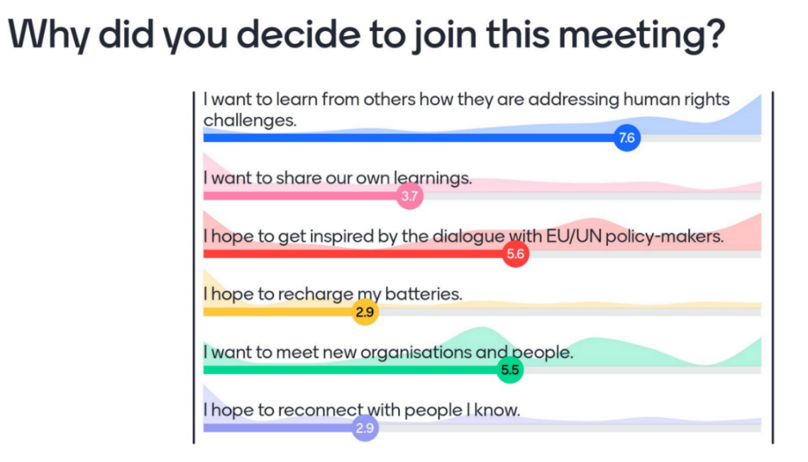

Keynote by FRA Director
FRA Director Michael O’Flaherty acknowledged the personal, organisational, and societal impact that the COVID-19 pandemic has had over the past year. He also discussed what he hoped would come out of this meeting.
“The pandemic has been so impactful that it has sometimes impeded us from developing big picture strategies,” he said. “The purpose of this meeting is to come together, to map out those steps towards a better future.”
- In terms of personal experiences, everyone is in some way feeling worn out and exhausted by the pandemic. For many, this has been a period of deep pain and tragedy.
- Organisationally, the pandemic has been profoundly challenging. Work on the ground had to be postponed and some sources of income have dried up.
- The societal impact of the pandemic has been immense, with human rights threats and challenges across the EU. FRA has followed these closely and reported to policy makers.
- Moving forward, what unites every stakeholder is a fundamental concern for society. The language of human rights provides a fantastic basis for mutual learning and for understanding the realities in society.
- Participants should be aware that other elements in society might use different frames of reference. This underlines the need to communicate effectively and make arguments respectfully, in order to find common ground.
- There are reasons for hope. The entire human rights infrastructure has proven to be more resilient than many might have expected. Courts across Europe have also stood up for human rights, freedom, and dignity. National human rights institutions are rising to the moment.
- The pandemic has made certain social realities impossible to deny. Issues that have come to the fore include the power of social platforms, and how these should be used and regulated; the impact of artificial intelligence on our lives; patters of inequality; and the impact of social movements like Black Lives Matter.
- Instilling a sense of optimism, O’Flaherty gave the last word to Irish poet Seamus Heaney, quoting his poem “The Cure at Troy”:
“History says, Don't hope
On this side of the grave.
But then, once in a lifetime
The longed-for tidal wave
Of justice can rise up,
And hope and history rhyme.”

Breakout sessions
The 13 breakout sessions enabled participants to share experiences and learn from each other. Each session, hosted by different civil society organisations, focussed on finding ways to tackle and overcome challenges. The results from these sessions then fed into the high-level panel and discussion.
Civil society organisations hosted discussions on the following topics:
- Intersectional discrimination during the pandemic
- The impact of COVID-19 on persons with disabilities
- COVID-19 and the impact on racialised groups
- Children’s rights in the age of COVID-19
- Promoting the rights of young third-country nationals in alternative care services
- Tackling homelessness with a rights-based approach
- Travellers and Roma human rights during the COVID-19 crisis
- Women’s Rights in times of the Coronavirus pandemic
- Media accountability in covering human rights issues
- Addressing measures which restrict human rights and civic space at national level
- Defending civic space in times of pandemic
- Reclaiming the public space in times of pandemic
- Organisational learnings of CSOs work during COVID-19
Dialogue on ways forward with Commissioner Dalli, UN Special Rapporteur Lawlor and FRA Director O’Flaherty
Helena Dalli, the EU’s first Commissioner for Equality, acknowledged that 2020 has been a difficult year. The Coronavirus pandemic has exacerbated inequalities and placed vulnerable groups in even more precarious situations. At the same time, the EU’s policy framework on equality has never been stronger.
“We are determined to make the leap towards a true union of equality,” she said. “I look forward to hearing your experience and views on overcoming challenges, especially in the context of COVID-19.”
- The EU Anti-Racism Action Plan focuses on actively ensuring equal treatment for all. An Anti-Racism Summit ahead of the International Day for the Elimination of Racial Discrimination is scheduled for 19 March 2021.
- The EU Roma strategic framework for equality, inclusion and participation, published in October 2020, sets out a comprehensive approach to socio-economic inclusion of Roma. EU Member States are encouraged to develop, adopt and implement national Roma strategies by September 2021. The European Commission has also issued a proposal for a draft Council Recommendation on Roma equality, inclusion and participation.
- The EU’s first-ever LGBTIQ Strategy was presented in November 2020. The strategy sets out several targeted actions, including legal and funding measures, over the next five years.
- An initiative to extend the list of EU crimes to cover hate crime and hate speech is planned for the end of 2021.
- Headway has also been made on several key actions presented in the Gender Equality Strategy of March 2020. The European Commission plans to present a proposal for binding measures on gender-based violence before the end of 2021.
- A new disability rights strategy is also currently being finalised. The strategy will address the increased risk of poverty of people with disabilities and barriers to educational attainment.
Mary Lawlor, UN Special Rapporteur on the situation of human rights defenders, discussed her work in pursuing claims of violations that put human rights defenders at risk. She agreed that the COVID-19 pandemic has exposed vulnerable sections of society to further discrimination.
“Change is possible through your persistent work,” she told participants. “Times are tough, we know, but we have come through tough times before. When you are downhearted, remember you are agents of social change, and that the world would be much worse without your dedicated work.”
- Online communication has enabled human rights defenders to connect around the world. There is a need to build a safe digital environment for them.
- Things have in general improved. Some places are worse than they were in the 1970’s but most places are much better.
- Today, people are more aware of their rights than ever before, and there are more people in more countries working on human rights.

Key civil society recommendations from breakout sessions
First round of discussion: gender and age
Rapporteurs presented some of the key findings from the breakout sessions. The first group focused on child rights, refugee support, women’s rights and older LGBTIQ persons in the context of the Coronavirus pandemic.
- Child rights faced unprecedented challenges in 2020. These challenges seriously affected the wellbeing and mental health of children, and brought into focus issues such as domestic violence and the widening digital divide. The EU should put children at the heart of any recovery strategy. There needs to be a European Child Guarantee to tackle child poverty, as well as an enforced strategy to protect the rights of the child.
- Young refugees – The challenges faced by third country nationals, asylum seekers, young refugees, including unaccompanied minors coming of age, during the Coronavirus pandemic in the EU affect the right to education, as well as access and recognition of skills. A key issue is the situation they face after their transition to adulthood. Young refugees should be part of a necessary conversation on possible solutions and have their voices heard by policy makers.
- Women’s rights – Decision makers should continue to prioritise women’s rights, including sexual and reproductive rights, which are being undermined in some countries. Survivors of violence still need access to essential services. The EU should work closely with Member States to guarantee rights to all women and monitor the situation to ensure that legislation is being implemented. Targeted actions should be included in the future Multiannual Financial Framework, and the EU should ensure that funds do not support beneficiaries opposing women’s rights.
- Working with older LGBTI persons during the pandemic requires a focus on intersectionality. The pandemic has exposed systemic violations against older people and organisations that might not usually focus on older people are now taking their needs into account. Without disaggregated data, it is not possible to reach a full diagnosis of human rights violations. Few countries specifically consulted older people on actions during the pandemic.
Commissioner Dalli responded that the points made by civil society very much reflect her experience. The pandemic has brought to the surface many pre-existing issues. Women suffering from domestic violence is one example of this. Persons with disabilities who now find themselves even more isolated and excluded is another. The European Commission is committed to forcefully tackle these issues, which is why a standalone portfolio on equality was created.
Special Rapporteur Lawlor shared the concern about the intersectional nature of human rights violations. She noted that one of her priorities was to support the defenders of people with disabilities, who might themselves have a disability. She asked participants to inform her of anyone they know who might be targeted. She also asked participants to inform her of any child human right defenders who might be targeted because of her or his work.
Director O’Flaherty said that the point about intersectionality cannot be undervalued. We cannot take generic approaches to groups, he said. The appalling situation of Roma children is a case in point. It is also vital to work with the rights holders themselves. FRA also plans to ratchet up work in the area of violence against women in the near future.

Second round of discussion: vulnerable groups
A second group of rapporteurs discussed racism and COVID-19, the Roma, the impact of the pandemic on persons with disabilities, homelessness and poverty, and media discourses on migrants and minorities.
- It is critical to support civil society organisations and establish participatory mechanisms for minority-led organisations. There should be more flexibility in terms of funding, given the impact that the pandemic has had on the work of CSOs. There is the need to establish safe spaces for organisations and better frameworks for anti-racism defenders. Equality data disaggregated by racial or ethnic origin can help make discrimination of minorities more visible. Intersectional approaches and the adoption of national action plans on racism are needed. There needs to be more accountability regarding the disproportionate use of force by law enforcement which has been reported by CSOs in parts of the EU.
- Protecting and promoting Roma and Traveller rights during the pandemic requires engaging with all stakeholders. Overcoming strong anti-Roma sentiments remains a key challenge. All too often, anti-Roma discrimination is not framed as a human rights issue. The EU, and agencies like FRA, should work with civil society to ensure robust oversight of national strategies based on the new EU Roma strategic framework for equality, inclusion and participation for 2020-2030.
- Many rights violations affecting persons with disabilities have been recorded during the pandemic. Civil society has often replaced the role of public service providers. The crisis is not over, and challenges remain. The EU and national governments cannot ignore disability anymore. There is a need to accelerate efforts to facilitate independent living, and to monitor the implementation of such measures.
- Homelessness deprives people of their human rights. The root causes of homelessness are often structural, and these must be addressed. In addition, administrative practices often discriminate. Homelessness needs to be addressed through integrated approaches that successfully deliver on Principle 19 of the European Pillar of Social Rights. The Portuguese Presidency plans to hold a high-level conference on homeless people in Lisbon in June, aiming at the signing of a joint declaration.
- Common challenges in media coverage include hostile narratives and prejudices. Civil society organisations can develop tools to turn negative narratives into positive ones. Too often, vulnerable groups remain without a face or a story. Media literacy needs to be strengthened. The public needs to be informed and should demand accountability.
Special Rapporteur Lawlor noted that attacks on the civil society space have been going on for a long time. We can change the situation by continuing to be persistent and by continuing to make such attacks visible and speak out.
Commissioner Dalli noted that the Taskforce for Equality is working to ensure that equality is mainstreamed in all policy areas. Discussions with EU Member States to set up their own national equality taskforces are ongoing.
Director O’Flaherty pointed out that tackling anti-Roma discrimination remains a key priority for FRA. He predicted that the Portuguese Presidency Anti-Racism summit could be a key moment, and welcomed calls for continued investment in media literacy. FRA has a media toolkit on respecting human rights while reporting on migration.
Third round of discussion: civic space
The third group of rapporteurs discussed civic space issues, surveillance and the right to express your opinion through protest, freedom of assembly and association, and organisational responses to the coronavirus pandemic.
- Restrictions on civic space have been reported throughout the EU. The role of civil society in the rule of law discourse should be more present within EU institutions.
- Defending civic space during a pandemic requires civil society action. There have been reports of NGOs being de-registered, as well as attacks on freedom of assembly, and the right to express your opinion through protest. The EU should more proactively cooperate with civil society. Since courts are sometimes the last resort to uphold rights, funding is also required to support and defend litigation actions.
- Unlawful surveillance represents an invasion of privacy rights and freedom of assembly. There have been calls to ban biometric surveillance. Civil society organisations reported that facial recognition technology may have a discriminatory impact on minority groups.
- The Coronavirus pandemic has brought new challenges and restrictions. It is important that organisations remain as flexible and creative as possible. While some projects might be on hold, overall aims could be achieved by other means. It is also critical that civil society organisations do more to take care of their staff since psychological stress and overwork can take their toll on anyone.
Commissioner Dalli said that the pandemic has given global civil society a new sense of urgency and empowerment. Organisations have shown resilience, creativity, and adaptability.
Director O’Flaherty agreed that staff wellbeing was critical. He noted that FRA has published analysis and reports on the fundamental rights implications of the use of artificial intelligence, and he encouraged stakeholders to consult these. Civil society organisations working on the EU’s frontier play a critical role and they need to be supported and protected. Governments should also consult human rights experts more when developing policy in response of the Coronavirus pandemic.

Networking event
Participants met informally with FRA experts, international partners and other civil society organisations during the online networking event. Conversations revolved around seven key themes:
- Donor support in challenging times – dialogue with three major donors (European Commission – CERV programme, EEA and Norway Grants, Ariadne Network);
- “Unmute yourself!” – Joining the FRA Fundamental Rights Forum 2021 and the Fundamental Rights Dialogues;
- Effectively communicating rights during and after the pandemic;
- Make rights work in practice – civil society, human rights institutions, international monitoring and the EU Charter of Fundamental Rights;
- Today’s pressing issues for fair and equal societies in the EU and how to address them;
- Priority areas of work following the Pact on Migration and Asylum;
- How does FRA deliver in the area of justice, digitalisation and security?

Participants’ feedback
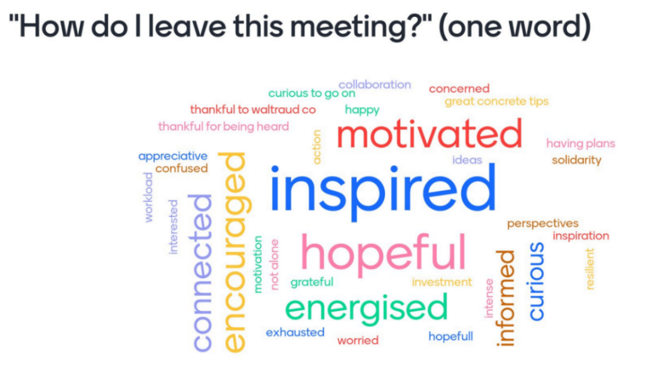

You can find the recordings of the plenary sessions online:
- Recordings Floor (EN) (opening + Part II): https://we.tl/t-GeSuxanrMY
- Recordings FR (opening + Part II): https://we.tl/t-cPnSPfMi6z

