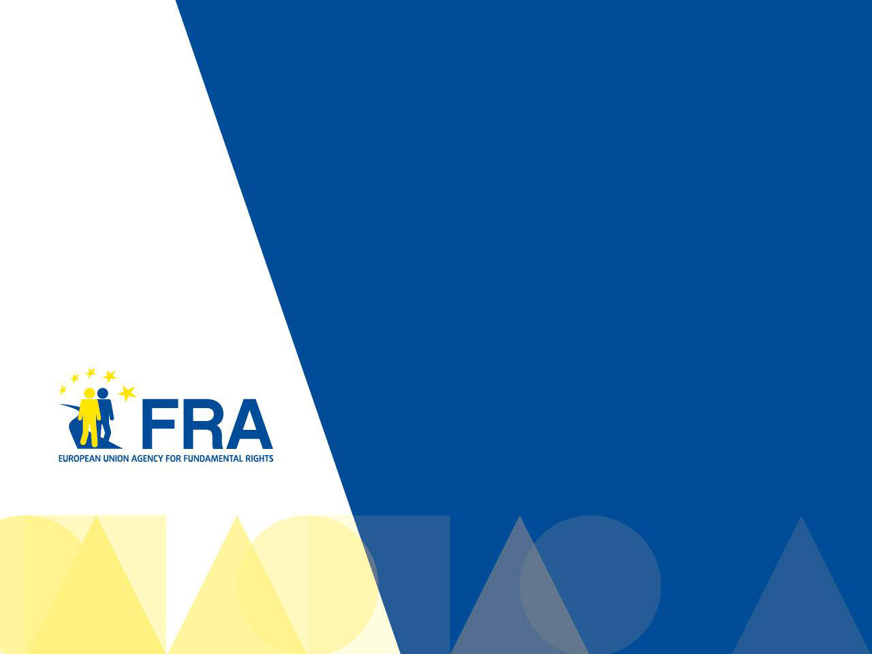
The rights of people with intellectual disabilities and people with

1
mental health problems

June 2011

WHO ARE WE?

The European Union Agency for Fundamental Rights is called FRA for short.

The FRA gives advice about how to protect people’s rights.

Rights are things all people are entitled to – people with disabilities as well. Another word for entitled is allowed.

The FRA is an organisation of the European Union.

2

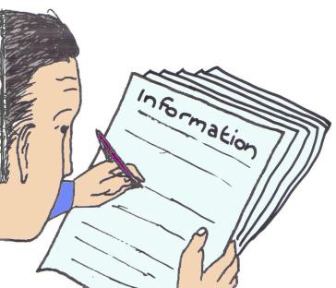

WHAT IS THIS PROJECT ABOUT?

The FRA collects information

about the rights of people with intellectual disabilities and the rights of people with mental health problems.

People with intellectual disabilities

find it hard
to learn new things.

People with mental health problems sometimes find it hard to cope with the normal stresses of life.

3

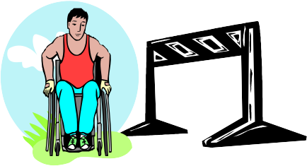

People with mental health problems and people with intellectual disabilities
are different from each other.

But they often face similar problems:

They face discrimination.

Discrimination is when one person or a group of people
are not treated in a fair way.

4

People with mental health problems and people with intellectual disabilities
are different from each other.

But they often face similar problems:

They are treated differently and unfairly.

This is because people have opinions of people with disabilities not based on facts.

5

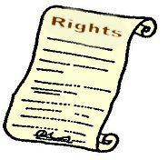

WHY DO WE DO THIS PROJECT?

FRA is doing this project to make sure that people with intellectual disabilities and

people with mental health problems

can enjoy their rights just as everyone else.

6

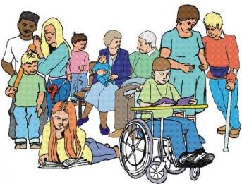
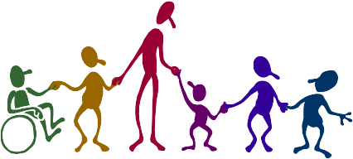

WHY DO WE DO THIS PROJECT?

To help explain the United Nations Convention on the rights of people with disabilities.

Convention is an agreement

between different countries

about a set of rights that apply to everyone. Countries who sign an agreement should do what the agreement says.

To help people with disabilities

live independently and be part of society.
7

WHAT WILL WE DO?

The FRA will collect and study information

about the laws that protect the rights of people with
disabilities

in the European Union.

- European law and the European Disability Strategy (2010-2020)

- The law of countries of the European Union

8

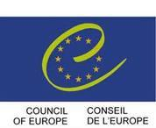

We will focus on important documents for the rights of people with disabilities.

These documents are called:

  - United Nations Convention on the Rights of People with Disabilities

  - European Convention on Human Rights

9

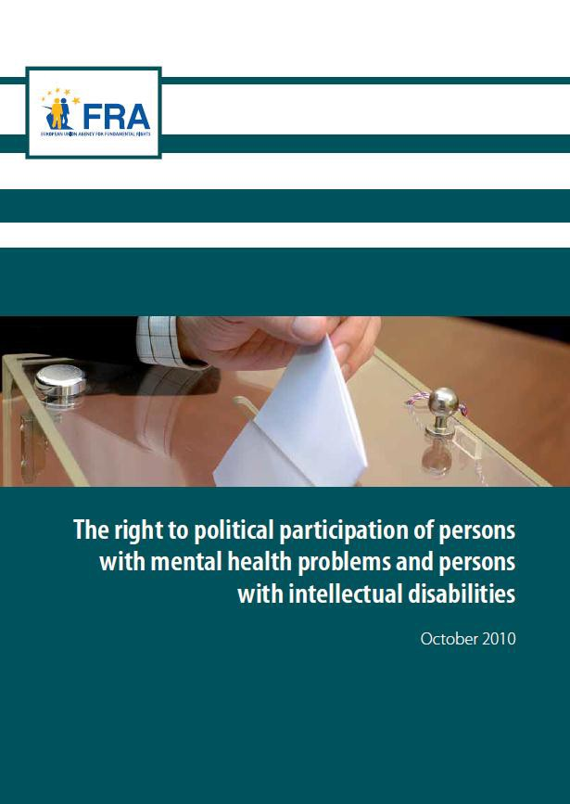
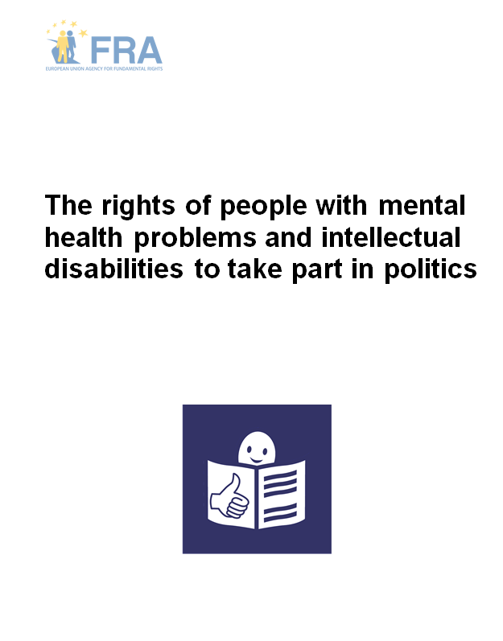

First report

10

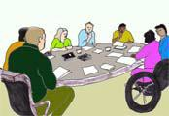

WHAT ELSE WILL WE DO?

FRA will work with other people and organisations
to find out more about the rights and the problems
that people with disabilities have.

For example the FRA will speak with politicians from the countries of the European Union.

FRA will speak with people who work or care
for people with disabilities,

for example personal assistants or parents.

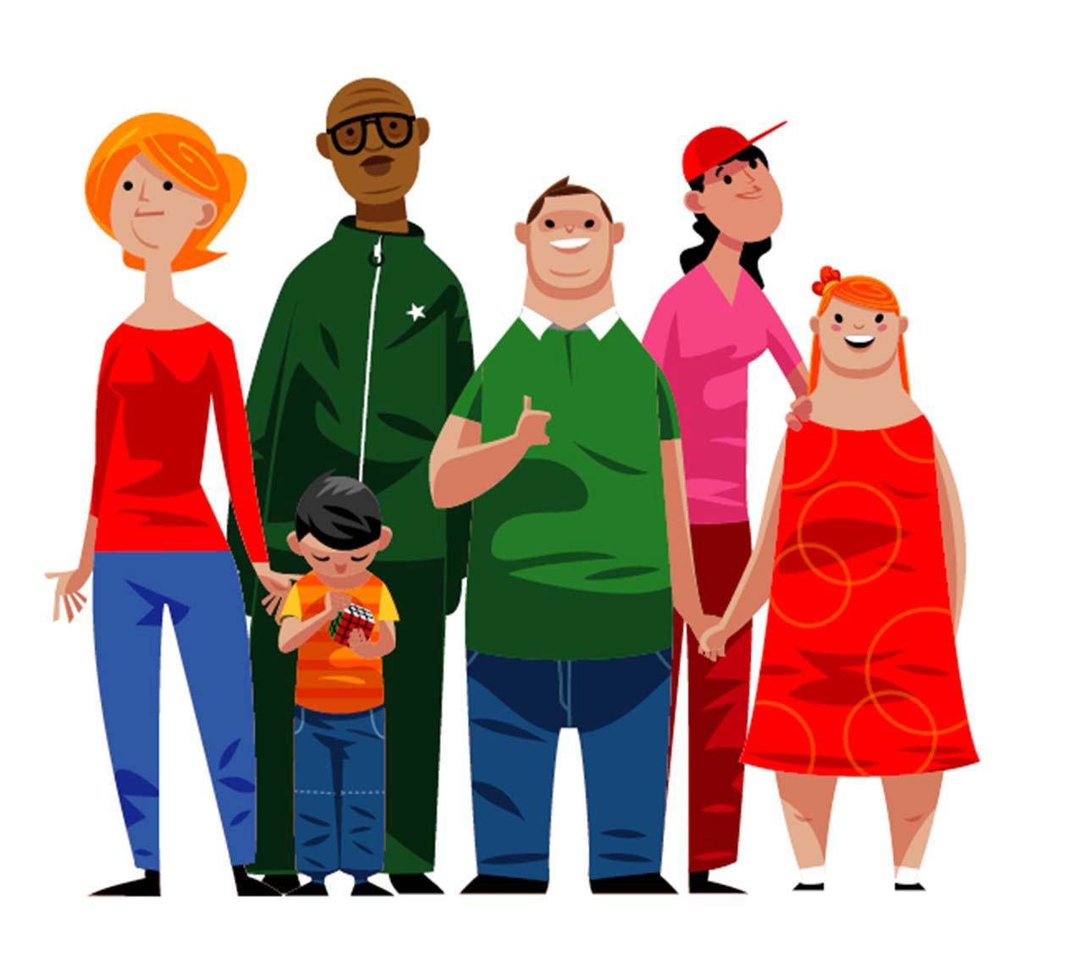

“Even if I cannot speak, it doesn’t mean I have nothing to say”

Person with an intellectual disability from Sweden

WHAT ELSE WILL WE DO?

The FRA will speak with

+ people with disabilities
to find out their opinion on their rights.

We will speak with people with disabilities in different countries in Europe. These countries are:

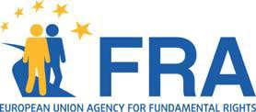
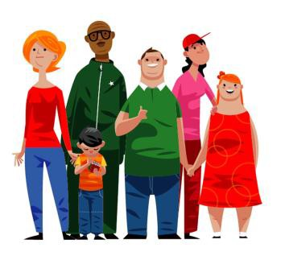
- Bulgaria

- France

- Germany

- Greece

- Hungary

- Latvia

- Romania

- Sweden

- United Kingdom

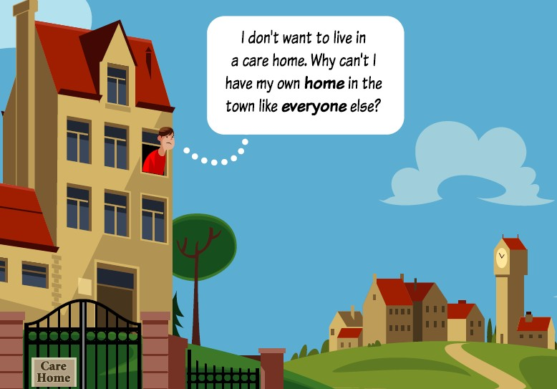

The FRA will talk with
people with disabilities about:

Their right to

live independently and make their own choices
about how and where to live.

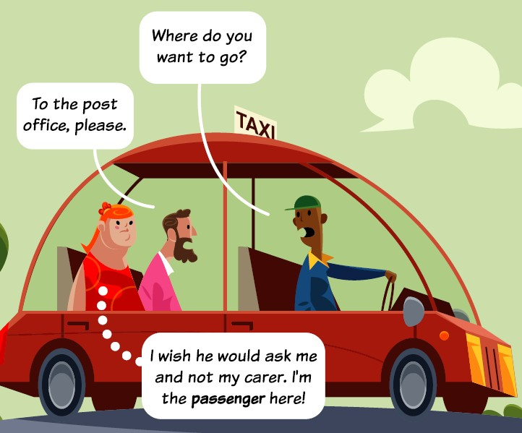

The FRA will talk with
people with disabilities about:

Their rights to be equal and treated respectfully and to make decisions for themselves.

15

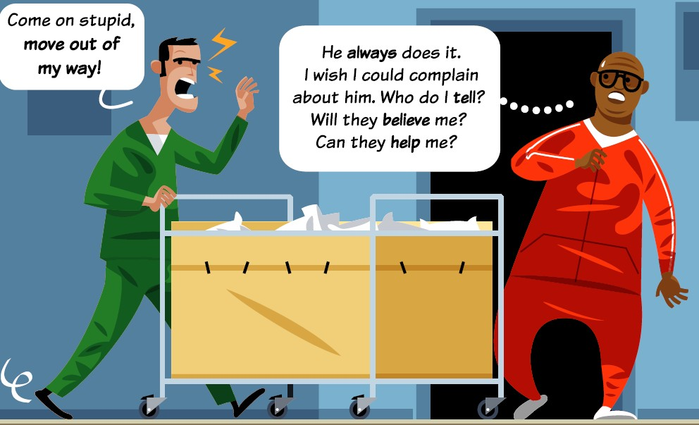

The FRA will talk with
people with disabilities about:

The protection of their rights in

places where people
look after them

and their protection from violence and abuse.

16

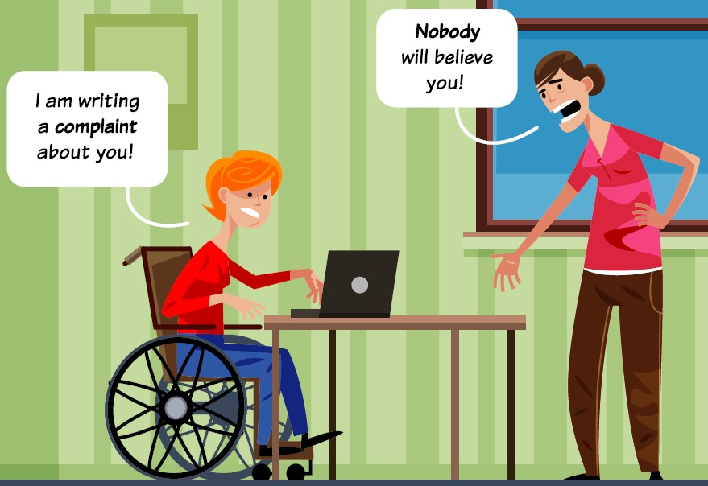

The FRA will talk with
people with disabilities about:

Their right to complain to a court
when their rights are not respected.

17

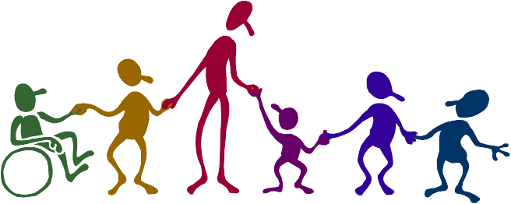

This will help the FRA
to better understand
what changes need to happen.

Then the FRA will be able
to tell people about the problems of people with disabilities.

The FRA will give some suggestions for how to make things better.

18

The information collected helps the European Union
and people who take decisions in
the European countries:

  - to promote equality and
  - protect the rights of persons with disabilities when they make new laws and decide on policies.

19

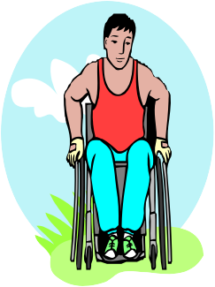

FRA wants everyone
to help remove the barriers
for people with disabilities.
=

FRA shows how much
people with disabilities can do
with the right help and support.

See our postcard on the next slides.

20

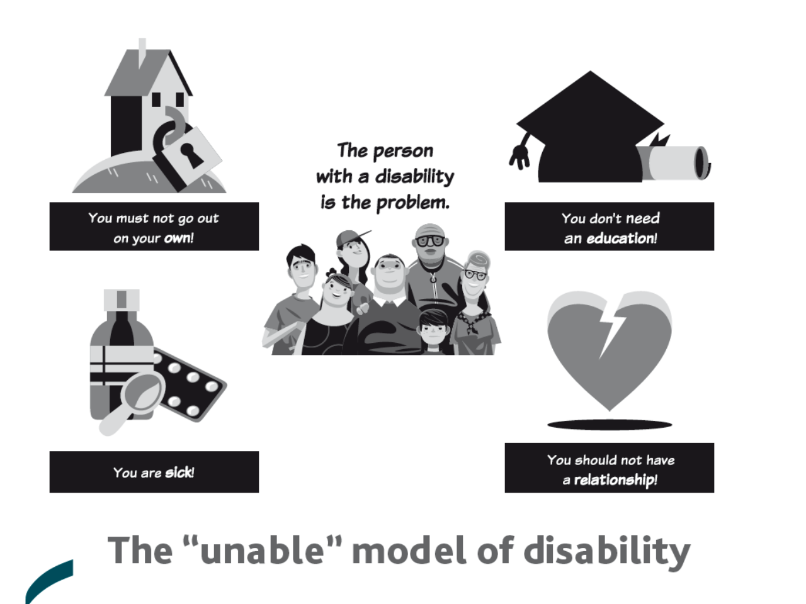

21

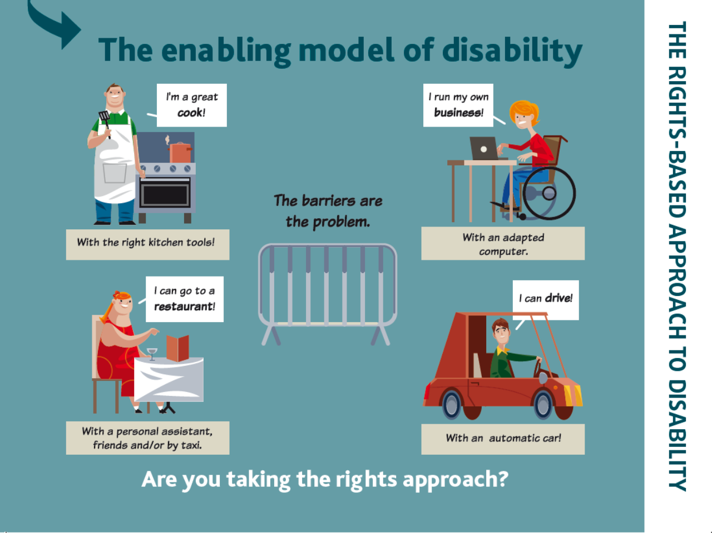

22

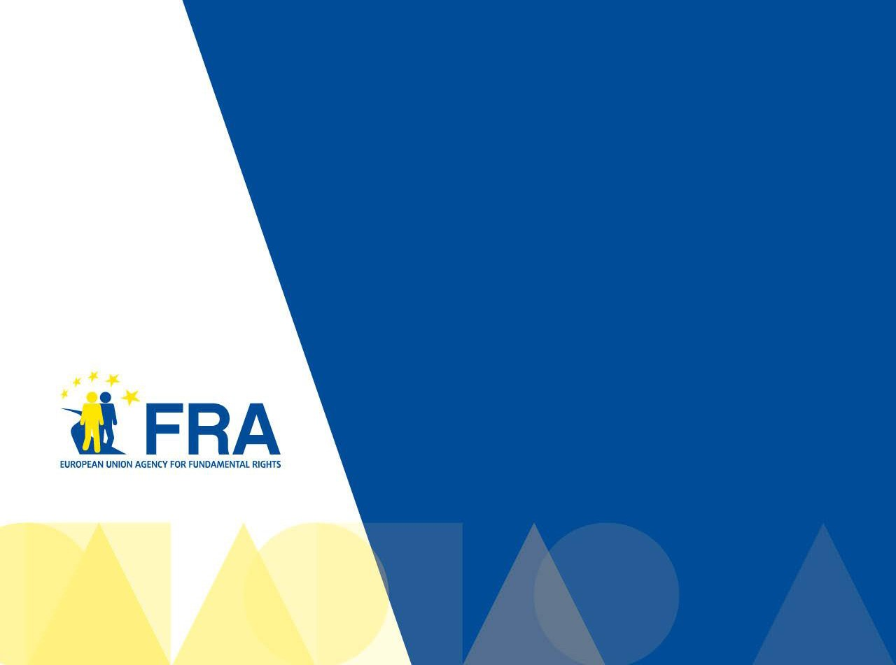

23

For more information

disability@fra.europa.eu

fra.europa.eu

